# 

# Table of contents

1. Profiles……………………………………………………………………………………………....3-6
2. Team Contract……………………………………………………………………………………….7
3. Project Selection ………………………………………………………………………………8-12
4. Project Proposal………………………………………………..……………………………13-21
5. Concept Design…………………………………………………………………………......22-33
6. Preliminary Project Design……………………………….…………………………….34-39
7. Technical Design Report…………………….………………………………………..…40-58

# 

# 

# 

# 

Team Contract

All team members shall do as follow to ensure the best and most successful work environment:

* Be on time
* If you are late, communicate
* Be patient
* Teach each other
* Be responsible
* Be honest
* Be encouraging
* Communicate on Slack
* Do not be stubborn when stubbornness is not required
* Ask questions if you have any
* Solve problems as they arise

# Project Selection

## Introduction

The members of our team individually brainstormed ideas that the whole team could potentially work on during the quarter. After researching different robots and ideas, each project idea was given a paragraph description under “Project Ideas”. Then, an overall group rating for each project was made in a “Decision Matrix”, allowing the group to narrow down the choices from five to three. These final three selections will be among those considered for the final project, which was selected in the very final section.

## Project Ideas

### Gardening Robot

This project would involve a robot that is able of managing the gardening of a plant. The steps in the planting process which the robot will be capable of are driving in soil, digging up soil, dropping a seed, watering the seed, and fertilizing the seed. This robot has real-world applications that involve simplifying the gardening and farming process that could be used on a personal or industrial level. The parts required for the robot would involve containers and release systems for the seeds, water, and fertilizer that would involve valves and switches. The digging process would involve a motor attached to a drill-like object. FarmBot Genesis is a similar robot on the market that can plant a seed with a seed injector and water it precisely, build regimens for taking care of a plant by using its sensors to detect outside conditions, detect weeds and destroy them too (FarmBot.io, 2016)

### Object rejection and counting machine (ORCM)

This project would be a robot whose purpose is to reject items that do not fulfill a specific condition, related to size and weight. This would be similar to the “conveyor belt sorting bot” created by Gurmeet Sharma that is able to sort objects based off height (Sharma, 2009). In this example, the object rejection and counting machine has a conveyor belt and a sensor that identifies the size of the object, if the object doesn’t fulfill the condition, it is pushed out of the conveyor belt. It is very useful for quality control and inventory in factories as it can sort out anything that does not satisfy a condition. For example, it can determine whether a tennis ball fulfills certain criteria for size and weight for them to correctly perform. It can also be applied to determine the type of coin based on the weight and size. This project will likely require buying parts because it has a conveyor belt system that uses two or more pulleys; and a load sensor to determine the weight. From the provided parts this project will require a DC motor.

### Companion Bot

This project would involve an autonomous robot that follows a device through Bluetooth or wireless communication. The robot would be similar to companion bots like Kuri, meant to follow a person around while providing auxiliary services (NBC News, 2017). Kuri is a companion bot that fulfills a wide range of functions that include recognition of faces, playing music or working as an alarm. The robot can respond to the touch and can moves around through any surface thanks to a set of sturdy wheels. Rather than providing all the same functionality as Kuri, the robot would only follow a person around and hold materials that person finds useful (water bottle, phone, speaker, etc.) These personal items will be able to add supportive services to the robot, such as playing music. This project would be useful as a prototype to see how people will want to interact with an autonomous companion bot. The project will focus on avoiding obstacles using distance sensors, following an object through Bluetooth communication, and 3-D printing a customized robot frame to fit the personal items. This project will require a Bluetooth-capable device to communicate with the robot, but a phone with such capabilities is owned by all members of the group.

### Stair Climbing Vehicle

Semi tracked vehicle with ability to climb stairs. Basic design would consist of four independently driven tracked wheels, and an adjustable wheelbase. Would need to have ability for object and environment detection and obstacle avoidance. Required parts would be infrared or some sort of LIDAR for object detection, on-board cameras for driver visuals, multiple motors and servos for movement. An example of the final robot would be like the robot designed by Transcend, which is built to assist police by climbing upstairs using a tread drive base (Transcend Tactical, 2018). Thought the example is much more complex than what is being planned, the robot can ascend 3 steps at a time in up and down articulated movements that produce a downward compression force.

### Kitchen Aid Robot

This project would be an autonomous robot that could crack an egg by following set movements, or a robot that could make a cookie dough given the specific amount of each ingredients. This robot will only focus on one single task following a pre-programmed set of movements similar to Molly’s Kitchen Robot prototype (UPHIGH, 2016). This bot will be able to use a motor to spin, raise, and lower the arm, and use precise movements to ensure nothing gets broken in the process. The robotic kitchen has a pair of fully articulated hands that reproduce human movements when cooking and is operated through a touch screen. This project will save people time and effort in cooking. To prevent it from crashing due to water, we would add water-proof layer to it.

## Decision Matrix

#### Table 1 - Decision Matrix

In our Decision Matrix (Table1), interest (Col.2) was our third most important category in order to keep us motivated throughout the quarter in order to want to spend time on this project. Plausibility (Col.3) was the most important category to our group since we all wanted a finished product at the end of the quarter with the parts provided. Similarly, versatility (Col.6) was our second most important category since we wanted to keep all interested team members involved in a project they could finish. Challenge potential (Col.4) was also considered so that if a particular part of the project was done quickly, there was the ability to increase the scope of the project. Also, challenge helps us think out of the box to help us solve problems that may come up. Finally, real-world usage (Col.5) was considered since our project is a prototype to solve a real-world issue.

### 1st Choice - Stair Climbing

The team thinks this project would provide a challenge in design and execution, and is thus our top choice. We also believe that the driving mechanics associated with independently powered wheels would be sufficient work for the mechanical, electronic, and programming sub-teams. There is potential in this project to be able to handle different stair sizes ranging from smaller than the robot’s wheels to human-designed stairs, meaning we can adapt this project to our engineering ability.

### 2nd Choice - Companion Bot

This project allows for a creative component and allowance for differing levels of complexity. The idea of making a robot for personal use is one that appealed to many members of the group, as it would serve our own purposes after it is complete. Also, the challenge of getting a robot to drive and follow a device should give the programming and electronics sub-team plenty to work on.

### 3rd Choice - Gardening Robot

This project is the most multifaceted of the three final projects since it will do more than just drive. The different subsystems required to fully garden a plant provide plenty of opportunities to design creatively and allow the project to adapt to our own skill sets. The practicality of the bot combined with the team involvement and ability to finish it make this one of our top three choices.

### Final Decision

As our final decision, we decided to work on the stair climbing robot due to its challenge potential for both the mechanical and electrical sub-teams. There are many possibilities in the design of the robot as well, which gives our team opportunity to brainstorm.

# Project Proposal

## Introduction

Robots are increasingly being integrated into working tasks to replace in many fields of applications such as military, security systems, agriculture and industry. The project’s goal is to prototype a specific implementation of a stair-climbing robot in order to contribute to the body of knowledge and work done in this field of robotics. The robot’s functionality will focus on being able to climb up a set of stairs as well as move over a flat surface, and rather than building the robot with expensive materials or the most advanced machinery, the project will focus on applying fundamental engineering principles and a relatively small budget to design, prototype, and build the robot. This will allow the project to be accessible and by any individual or group that has a basic understanding of engineering design, such as students in an undergraduate introductory engineering course.

## Problem Statement

For military/police investigation, surveillance, urban search and rescue missions is often necessary to place sensors and cameras to get better awareness for the rescue personnel on the situation in order to determine how to proceed, for this reason stair climbing robots are a great alternative to reach dangerous or inaccessible areas just by the use of a control remote. Robots have a clear advantage over humans in these situations and the benefits to this operation of rescue robots, such as a stair climbing robot, include reduced personnel requirements, reduced fatigue, and access to unreachable areas. Robots are predestined to complete this task, but the requirements for such mobile systems are demanding. They should be quick and agile and, at the same time, be able to deal with rough terrain and even to climb stairs. By finding effective ways for robots to climb stairs, the safety of professions including firefighting, relief workers, soldiers, police officers, security guards, and professional movers will increase.

## Objectives

### Moving on a Flat Surface

The robot should be able to move on a level ground at a constant speed of 0.894 mps. We decided the speed taking as a reference the walking speed. Constant speed is important for comfortable driving over surfaces that aren’t stairs, which many stair-climbing robots might also be forced to do.

### Moving up an inclined surface

The robot should be able to drive up a smooth inclined surface, specifically a wheelchair accessible ramp. The angle of the inclined surface is approximately 4.76°, which is the required angle by the Americans with Disabilities Act. Our robot needs to successfully climb a ramp in order to achieve the simple task of climbing up an incline that a normal wheelchair would be able to do, which has a length of approximately 4 feet. This value is also determined by the Americans with Disabilities Act.

The robot should be able to climb one single step of stairs and stop on that stair, its body being completely on the stair. This is important to test the capability of our robot when climbing over smaller obstacles, such as a small hill or sidewalk. If the robot cannot climb a single stair, there is no possibility the robot can climb the rest of the stairs.

The robot should be able to climb an entire flight of stairs without stopping. This is the main goal of the project, as being able to climb a set of stairs without being stopped by any technical problem since it is most likely that in the use of urban areas the robot will be required to move from one location to another. The chosen set of stairs to climb fully is the main stairs of Area 01 in Maple Hall on the campus of University of Washington.

The robot can climb an entire flight of stairs with the ability to stop part way through before continuing to climb. This is important to ensure that if a robot stalls on a staircase that it is able to recover and continue executing its mission. The chosen set of stairs to climb, stop, and continue climbing is the main stairs of Area 01 in Maple Hall on the campus of University of Washington.

### Climbing a set of Stairs with Each Individual Step at a Fixed Type

Even though there are many types of stairs, the prototype will focus on climbing a specific set of stairs, which are a combination of boxes stacked on top of each other. The height of the stairs is 3.5’’. This height was determined by the height that was 70% the diameter of the wheels, a reasonable task for a robot. We decided this type of was acceptable given the budget and power constraints of the robot. The robot will successfully accomplish this goal if it can climb up and down the flight of stairs without stopping.

### Driving the Robot through Bluetooth

The robot should be able to connect to a Bluetooth-enabled device that will give it instructions to move up a flight and stairs and move down. Remote control is essential to make sure the robot can perform in environments that humans cannot easily access. The robot will have accomplished this goal if it can move, brake, change direction, and do all tasks stated previously while receiving directions from a Bluetooth device.

### Carry a payload of 1.5 kg

Being able to carry additional equipment beyond its own weight adds a large amount of versatility to the possible uses of the robot. This could include:

* + Carrying a camera to allow the pilot to operate it without a line of sight.
  + Deliver small parcels, such as supplies to someone who is trapped inside a building.
  + Allow for the use of more robust and heavy parts if necessary.

We chose 1.5 kilograms as this is heavier than the weight of many common objects, as well as 1.5 liters of water, most types of batteries, and standard medical kits. The robot will successfully accomplish this goal if it can do all tasks stated previously on the chosen set of stairs.

## Background Research

Stair climbing robots aren’t something this project needs to invent. There are numerous working designs for such robots that have been implemented for different uses (Robotpark ACADEMY, 2013). This project will not just copy one of these designs because, besides simply wanting to design something new and unique, there are different restraints and goals. For example, limits in time, money, and resources restrict certain designs, such as those with articulating legs (Lucidarme 2008). Also, the simpler designs, such as DeeDeLogists arch bot ("Stair Climbing Robot by DeeDeLogist" 2011), should not be used since the team has agreed on a certain level of challenge to meet. While another design will not be copied, common elements of functional stair climbing robots can be incorporated to the design of a new robot around this project’s constraints.

Many of the important features of stair climbing robots are based on where the robot comes in contact with the stairs. The main goal in this area is to enable the robot to push itself up the stairs without its contact points slipping down. The simplest way this is done is by using a material with a high coefficient of friction, like rubber (Townsend 2002), as the contact surface. Most robots also use a dynamic base that in some manner changes to better conform to the stairs and maintain constant contact as the robot goes up. This can be done by using flexible treads that bend to the surface of the stairs ("Stair Climbing Robots And High-Grip Crawlers | Intech" 2010), robots with multiple pivoting wheels (Watt 2011, Mohan 2014), pivoting treads (Lucidarme 2008, "Stair Climbing Mobile Robot - ARTI: Rugged Commercial Platform | Transcend Robotics" 2016, "Stair Climbing Robot" 2011), or even static “wheels” that are designed in such a way to change their effective radius as they rotate to match the shape of the stairs ("Stair Climbing Robot" n.d., "Stair Climbing Robot (Triple Bended Crosswheels)" 2013, Yap 2017). Designing with this in mind will ensure that this robot will maximize the amount of static friction, as opposed to the weaker kinetic friction (Townsend 2002), enabling the robot to push itself up the stairs instead of stationarity spinning its wheels.

Another important aspect of a stair climbing robot is managing its center of gravity and base of support (Gupta 2015). Even if the robot can stop from sliding down the stairs, there is still the possibility of it tipping over. In bipedal walking/climbing systems, a system’s center of gravity will go outside the base of support, because in essence bipedal walking is repeatedly falling and catching oneself ("Base of Support" 2017). This project will have a bipedal climbing system for this reason it will always have to keep the center of gravity above the base of support. By moving on the ground this is simple, using four wheels as the outermost points on a vehicle will ensure the center of gravity is always above the base of support. On an incline like stairs, however, the base of support becomes smaller and the center of gravity moves backwards. Both the base of support and center of gravity also change as the robot goes over the bumps of the stairs. To overcome these challenges stair climbing robots are generally designed with low centers of gravity, so the change is not as large and with wide bases of support. Most robots are also designed to counteract the oscillating surface of stairs, such as by designing the wheels to minimize change in center of gravity. Designs like that include the crossbend wheel robots ("Stair Climbing Robot (Triple Bended Crosswheels)" 2013, Yap 2017) or independently moving sectioned robots (Lucidarme 2008, "Stair Climbing Mobile Robot - ARTI: Rugged Commercial Platform | Transcend Robotics" 2016). By using these principles, the robot will be able to ascend without tipping or rolling down the stairs.

The final research consideration to make is what type of robots will be possible to build with the materials and methods available. With access to 3D printing technology, the manufacturing of parts that would normally increase a budget, like a planetary reduction gear set ("Planetary Gear by Ngoodger" 2014), can be done at a fraction of the cost. While rubber tread may be too expensive to purchase, 3D printing tank tracks ("Continuous Tank Treads by Whowhatwhere" 2010) and assembling them is a cheaper alternative. If a wheeled design is chosen instead, a laser cutter can do most of the work. Prototyping different wheel designs in cardboard can also be done conveniently before cutting the final wheels out of other materials. These tools provide considerable freedom in developing the robot.

## Plan of Action

### Using Tracks

Firstly, tracks provide a larger surface area engaged with the stairs, as opposed to wheels which have an extremely small area touching the surface. Secondly, 3D printable track links are already available online, along with compatible drive wheels. Additionally, tracks allow us to modify the size and shape of the track without having to remodel anything, links can simply be added and removed.

### Two Tread Pairs

A robot that only used one pair of treads (similar to a tank) would experience a higher degree of center of gravity shift & base of support reduction, causing tipping to be more likely. Three or more pairs of treads would add a large amount of work and would be unlikely to fit within the size constraints. Two pairs affords a flexibility between the chassis and the tracks without making the system too complicated. Additionally, the triangular shape is the strongest one because it is an inherently rigid structure, as the angle between the sides is determined directly by the length of the sides, as opposed to shapes with more than three sides where the angle and length of the sides are independent of one another. The robot will have four individually powered tracks of isosceles triangle (two sides of equal length).

### Slot for Additional Weight in Middle/Electronics

A specific area designed to hold our mass will help prevent unexpected shifts in the weight that could cause the robot to slide or topple over. Electronics will also be stored in the middle of the robot, including the Arduino, breadboard, and main wiring, battery, and Bluetooth receiver. This is to keep the center of mass as close to the middle of the robot as possible to prevent sideways tipping.

### Independently Powered and Controlled Treads

In order to successfully achieve our design goal of climbing stairs, we plan to give each tread its own power source to increases the torque/output of each tread. Using controlled treads gives us the advantage of less drivetrain or other power transfer system which decreases the design complexity and reduces number of parts that can fail. The high-flexibility feature of controlled treads increases the robot’s mobility and allows the robot have different treads moving toward different directions and at a various speeds and do regular and zero-point turning.

## Bill of Materials

#### Table 2 – Bill of Materials (original)

## Development Plan

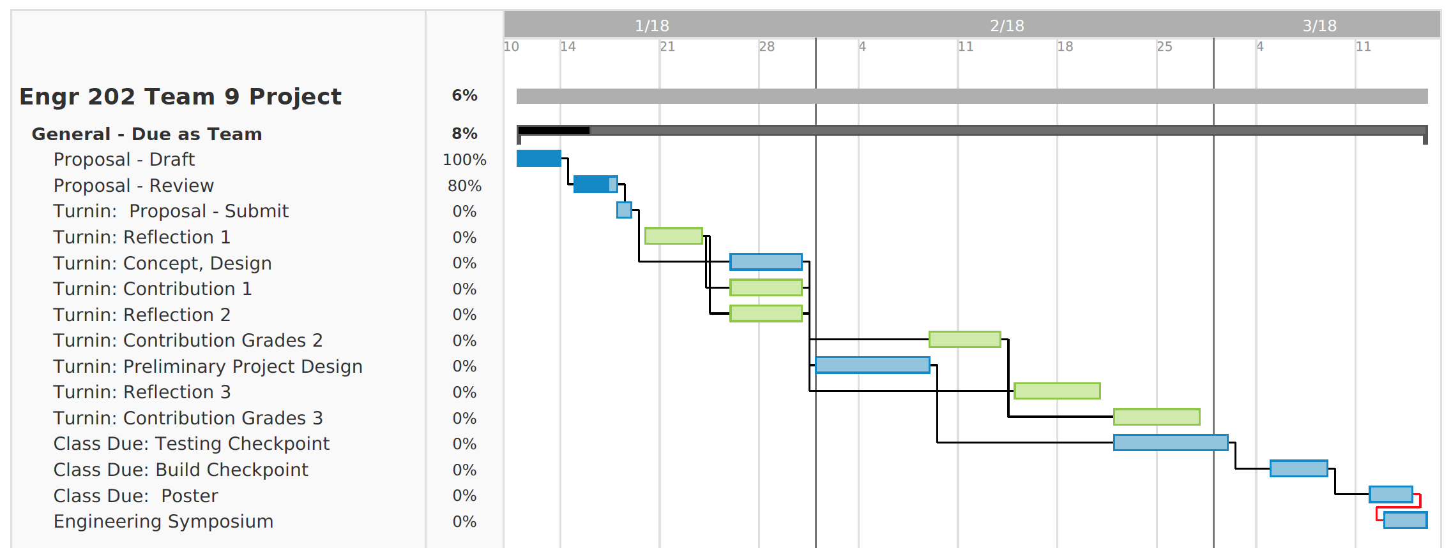

#### Table 4.1 – General Development Plan

*Table 4.1* lists out all the group project assignments’ due date and gives a clear timeline for the design process. It serves as notice board for reminding each team member of their own duty.

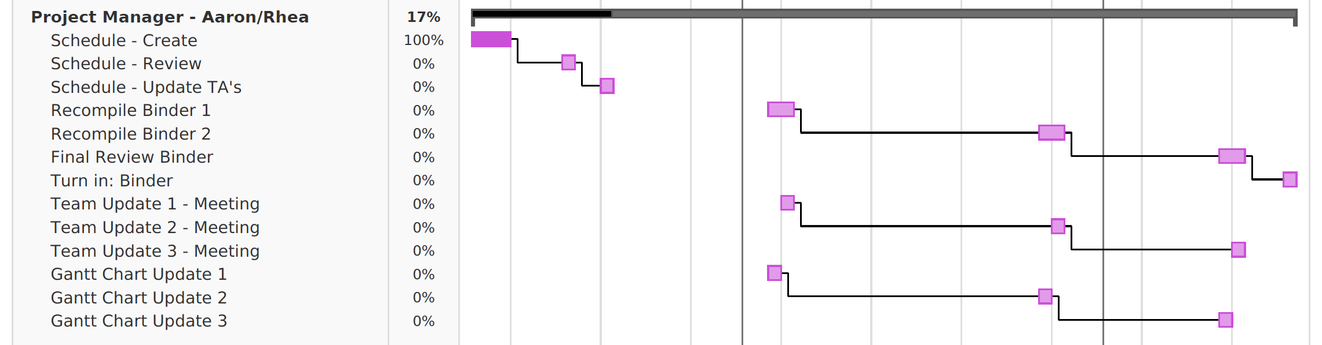

#### Table 4.2 – Project Management Plan

*Table 4.2* is meant to facilitate better team communication for higher productivity.

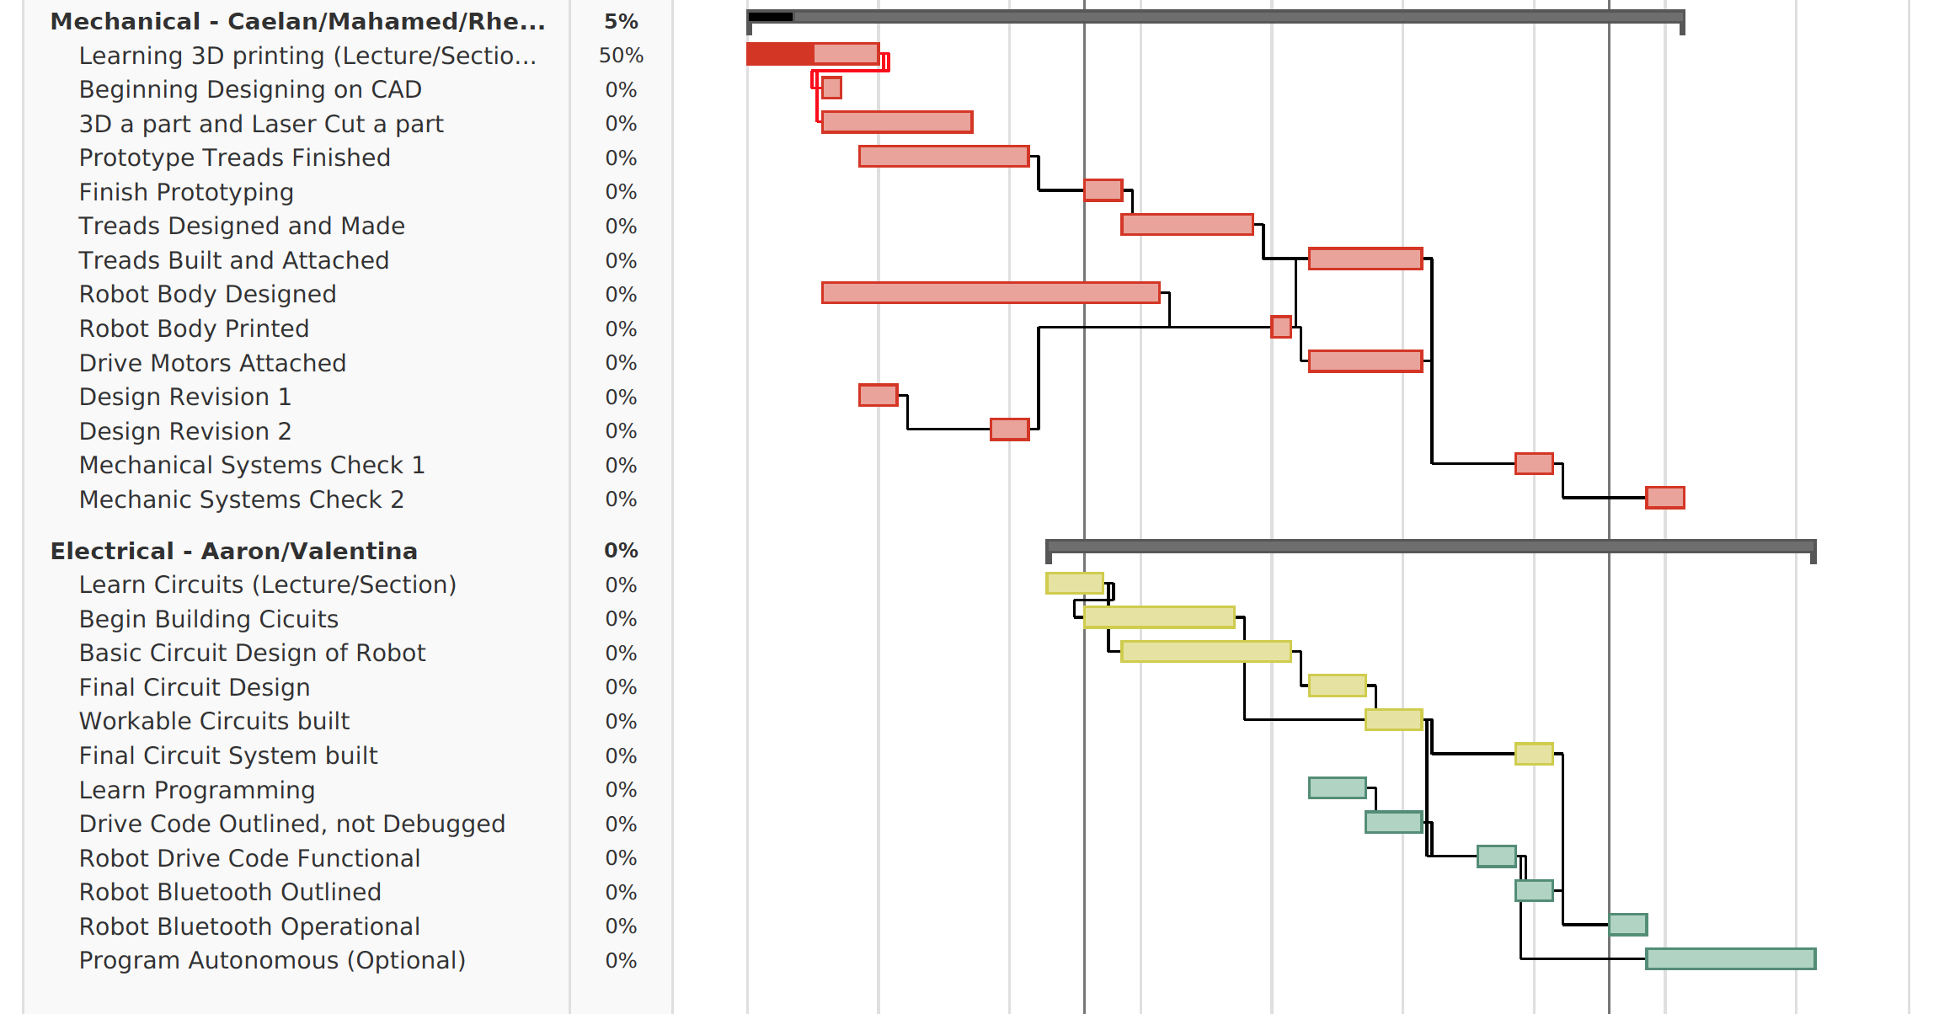

#### Table 4.3 - Mechanical & Electrical Development Plan

*Table 4.3* relies on our ENGR202 course progress. Our knowledge level in these two domains is the main constraints of our project development plan. It provides a clear development guideline for both teams based on our course schedule and group assignment due dates.

## Conclusion

A stair climbing robot has applications in a variety of settings and situations where human lives are at risk of danger for these reason there are many applications of stair climbing robots in the military, disaster aid, and professional moving industries that we hope to build upon and incorporate into a unique design. The project will strive to accomplish all goals related to climbing stairs, including stopping on a flight of stairs as well as carrying a payload, and moving over a flat surface at a constant speed. By focusing on executing fundamental engineering design principles and enhancing designs from previous implementations, the project will be able to successfully create a stair climbing robot.

# Concept Design

## Design Requirements

The project will be a Bluetooth-driven, stair-climbing robot. The robot will be capable of climbing stairs of which each step is 5 inches tall and 12 inches long through a multi-wheeled design. The robot will also have to pull up a 1.5-kilogram weight, making the design of the robot light and sturdy but also requiring independently driven wheels. Finally, the robot will have to have its own power source and Arduino in order to be controlled over Bluetooth.

## User Interface

#### Figure 1 - Screen Interface 1: Power Off

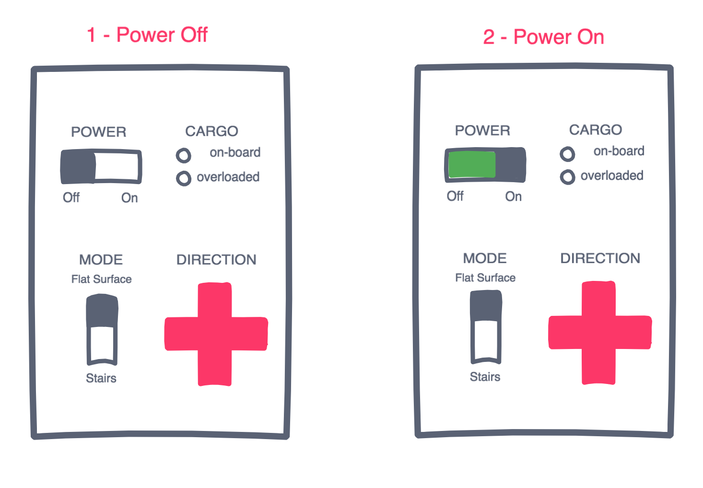The main users of the project will be staffs or drivers who will control the robot to travel to a desired destination, either with or without cargos. Our users are intended to have similar skill and ability as actual users of a commercial stair-climbing robot, such as security officials, military officers, or professional movers. Considering our users’ diverse cognitive affordances, such as language, and education background, we will implement our user interface on either a tablet or on a remote controller, with buttons labeled with universal symbols and colored in shared convention.

There will be a direct screen interface on the application of the robot as well as a direct non-screen interface on the robot. The “power” switch will be both on the robot and on the application and will function as the regular and emergency stop button to cut power to all robot systems. The “power” switch control will be in passive mode: it requires user input to turn on and turn off the power. The application will provide further interaction with the robot as it provides direction buttons that take inputs from users. The robot will also take a series of implicit inputs as default values including the surface mode (flat, incline, or stairs) and the weight of the robot. The direction switch will be in active modes: if the user doesn’t press any direction, the robot will not move.

Several of the indirect interfaces include lights to indicate if the robot is loaded with cargo and to indicate if the robot is in “drive” mode. The constraints of the robot include the restriction on movement if the robot is overweight or if the robot is not in drive mode.

## System Environment

The complexity of stair‐climbing involves more than climbing over an obstacle or going up a slope. For this reason, it is important to take into account the environment in which the system will be operating. The system is expected to operate in a flight of stairs by being able to climb steps one at a time. The location will be Maple Hall in the University of Washington. Each step will have a height of 5⅝ inches, and the stairs will vary in characteristics such as the material and whether or not it is a backed stair. There will also be external entities that may interact with the system such as the weight that the stair climbing robot will be carrying, which will be approximately 1.5 kg.

Since the environment in which the system is expected to operate may vary greatly, this will affect the functionality of the robot. A backless stair means that as the robot moves up the flight of stairs, it can fall through the gap while in the process of moving from one step to another. This means that the robot will have to have a large chassis and large wheels to avoid falling through. Also, the different materials of the stairs may affect the mobility of the robot, with surfaces such as carpeted stairs producing more friction with the wheels. This means the wheel design has to be versatile in order to be slicker on rough surfaces and grip on smooth surfaces.

In terms of external factors to the stairs, people walking up or down the stairs can impede the robot’s movement. In addition, if the robot were to drive outdoors, precipitation or wind can also cause problems for the robot’s stair traversal. Currently the robot is only intended to be driven indoors, but an outdoor modification for the robot would include shielding for the electronics and sensors to detect for people.

## System Input/ Output

*Figure 1* details how the robot will process different Bluetooth commands it will be given. The commands will be a variety of driving instructions that can cause the robot to go in four different direction; forward, backward, to the left and forward, and to the right and forward. The Arduino on board of the robot will interpret each command and power the motors in the commanded way. The direct processes occurring on the Arduino will be certain motor operations given to each of the independently powered wheels. This will include instructions for the number of rotations each motor needs to make (given in units of seconds) and a direction (a Boolean value for forward if true and backwards for false). In the case of all wheels given a time and positive Boolean, the robot will drive forward. In the same case but a negative Boolean, the robot will drive backward. In the case only the right wheels are told to drive, the robot will turn right. In the case only the left wheels are told to drive, the robot will turn left.

#### Figure 2 - I/O Diagram

## Concept Sketches

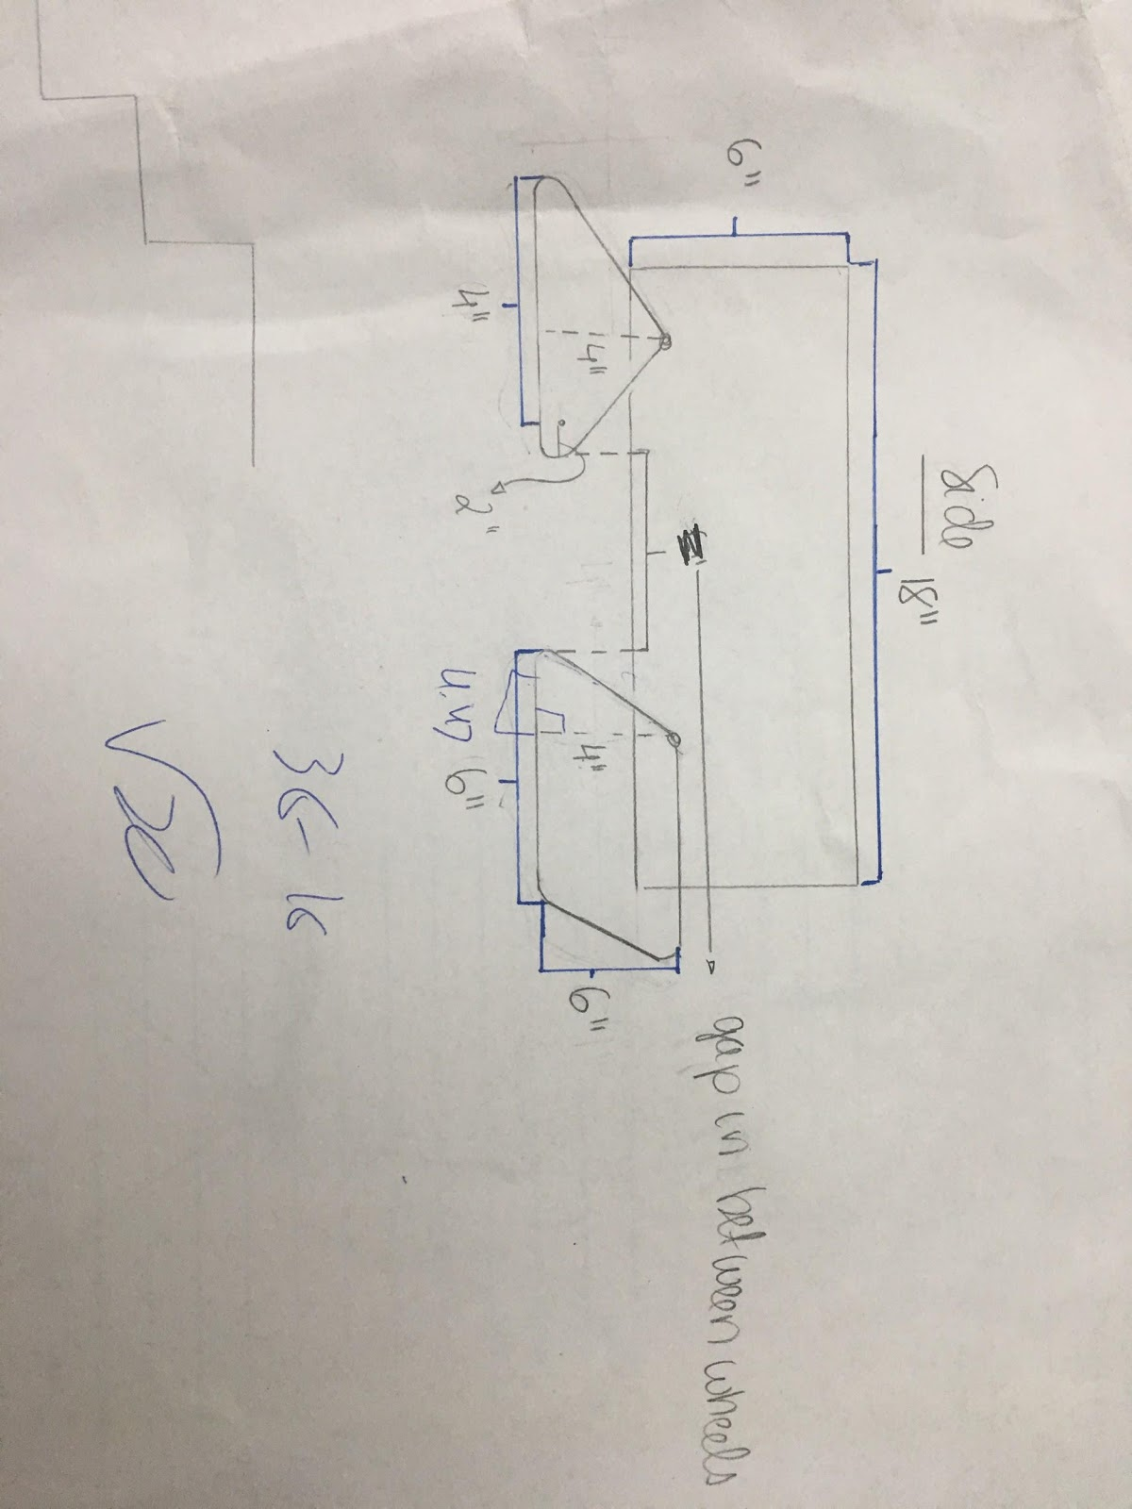

*Figure 3 - Sketch 1: Concept Design (side view)*

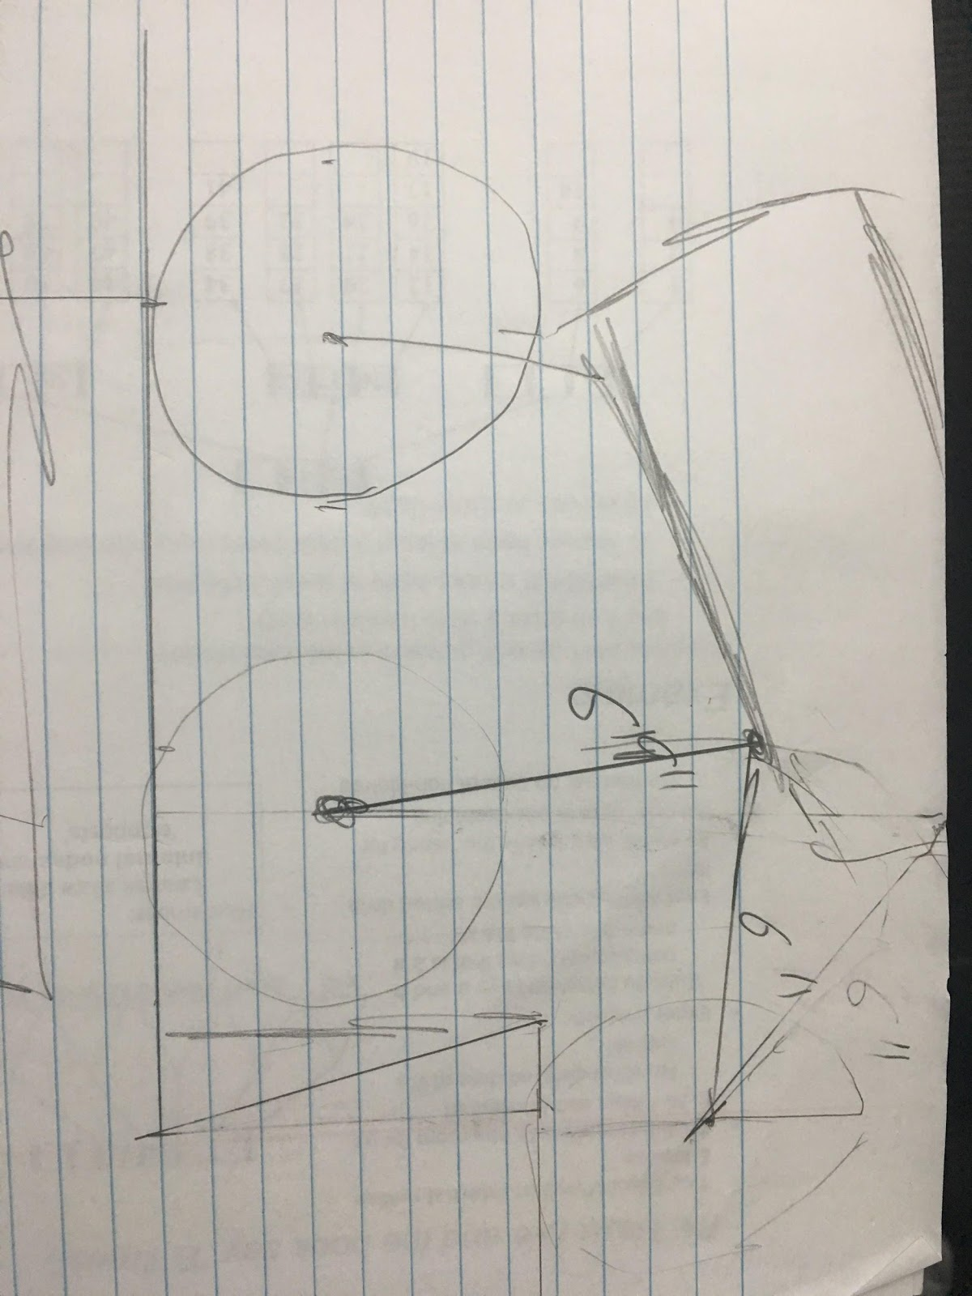

#### Figure 4 - Sketch 2: Ideal Climbing (side view)

## Preliminary Technical Drawing

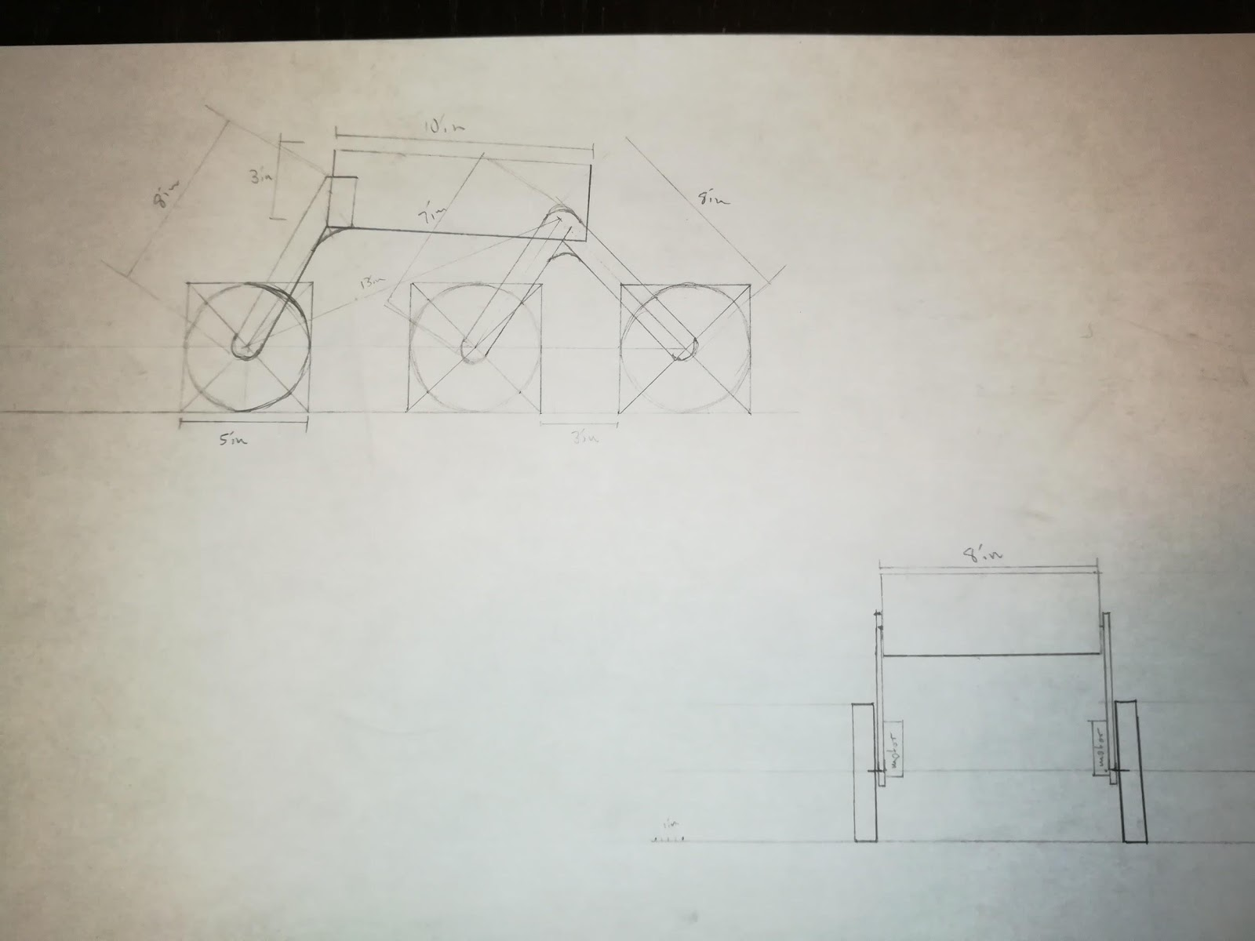

#### Figure 5 - Sketch 3: Preliminary Technical Sketch (side view)

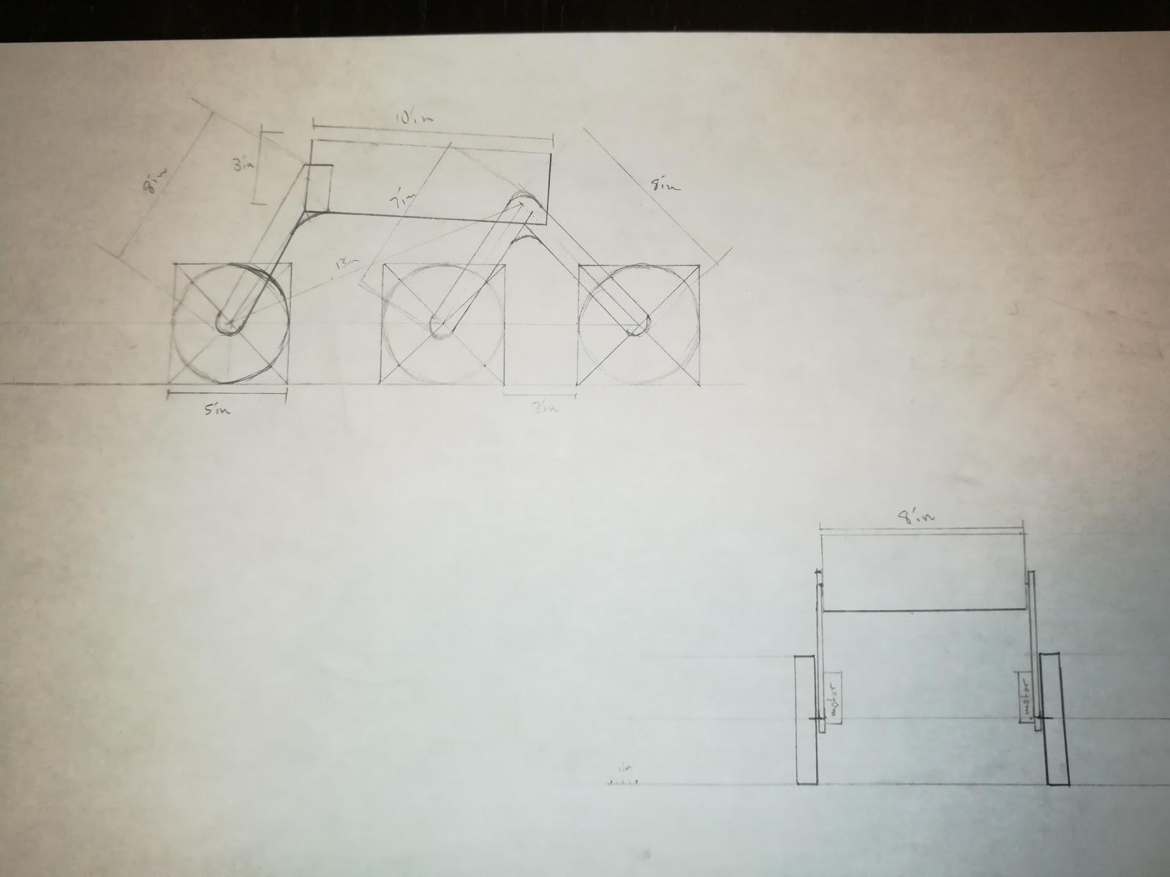

#### Figure 6 - Sketch 4: Preliminary Technical Sketch (front view)

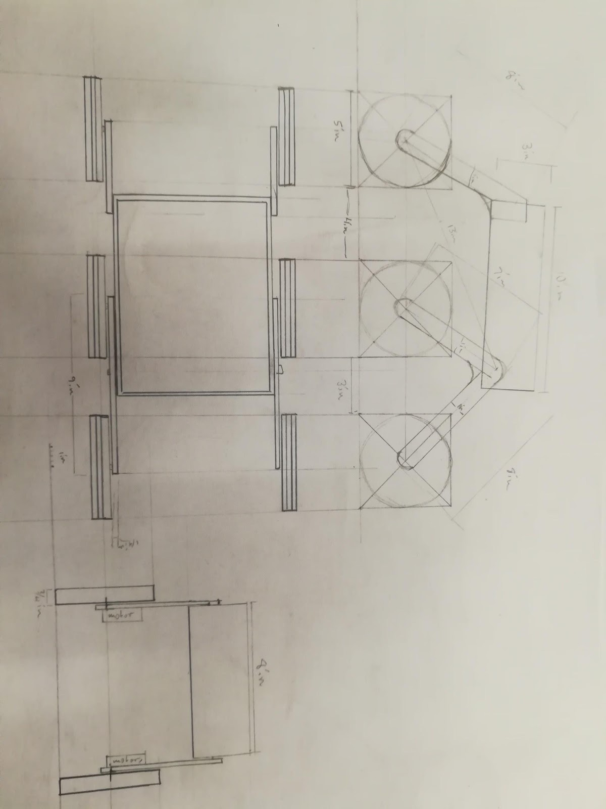

#### Figure 7 - Side, front and top view of Preliminary Technical Sketch

The first design *(Figure 5 and 6)* will have a 6-wheel design with the forward two front wheels attached together to better climb stairs and the back wheel providing stable support (*Figure 5)*. Each wheel will be of the same composition and size. The brackets that attach the chassis to the wheels will also include springs *(Figure 5)* which will allow controlled movement of the wheels. Each wheel will also have attached motors on the underside of the robot *(Figure 6)*. The chassis is meant to be small and lightweight in order to store the battery, Arduino, Bluetooth module, and additional weight in a safe and enclosed manner.

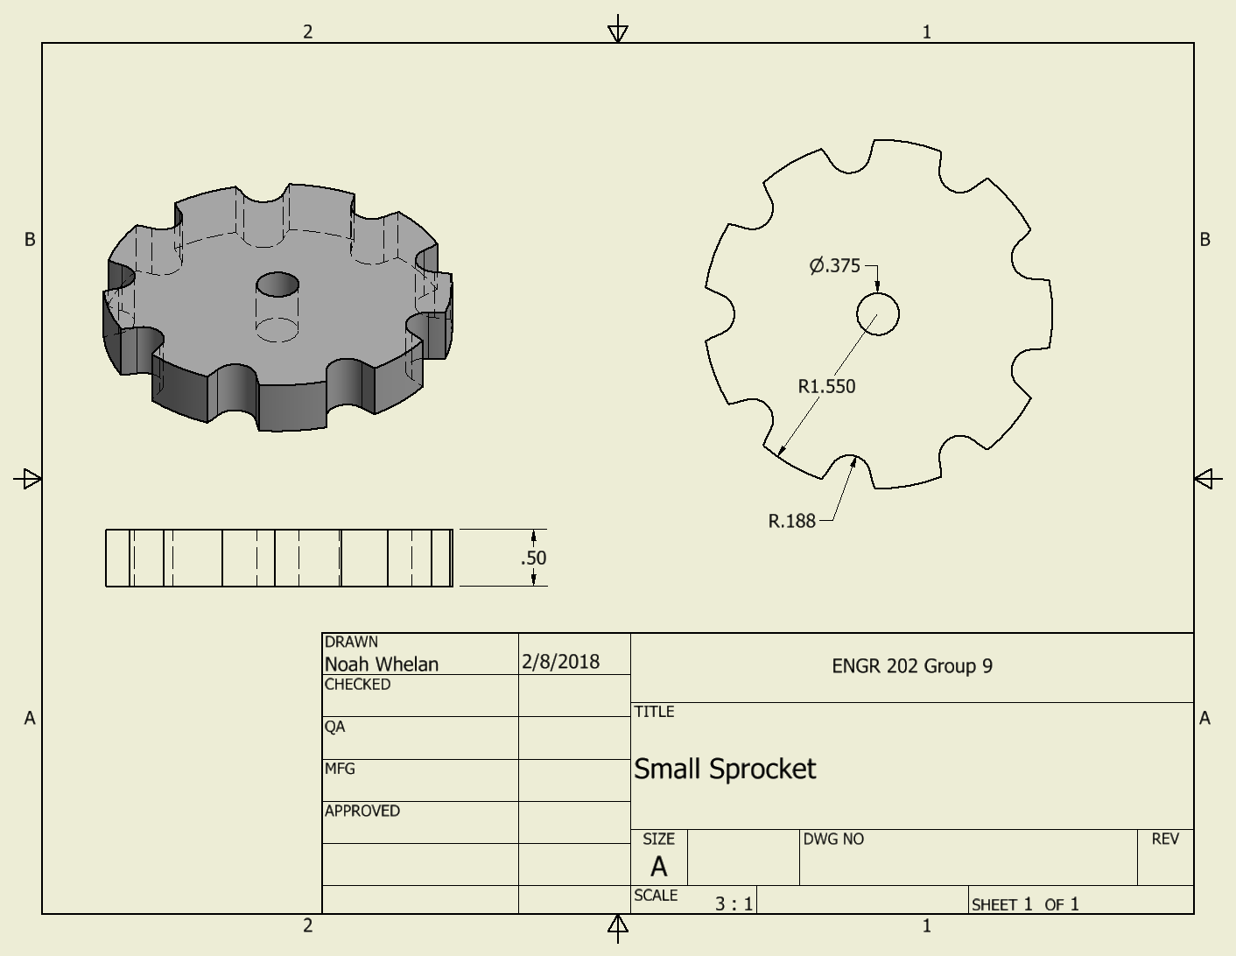

#### Figure 8 - Preliminary Design 1: Small Sprocket

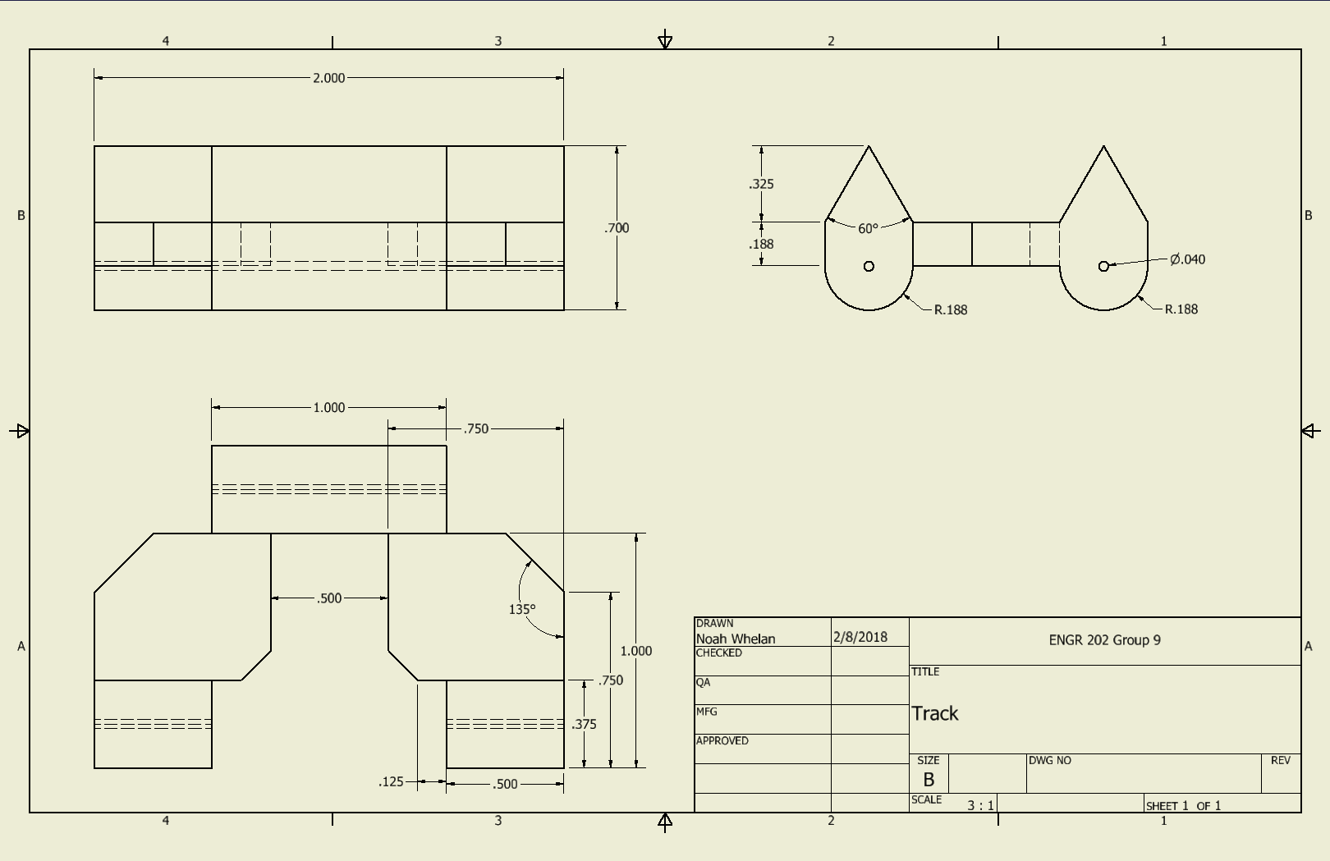

#### Figure 9 - Preliminary Design 2: Track

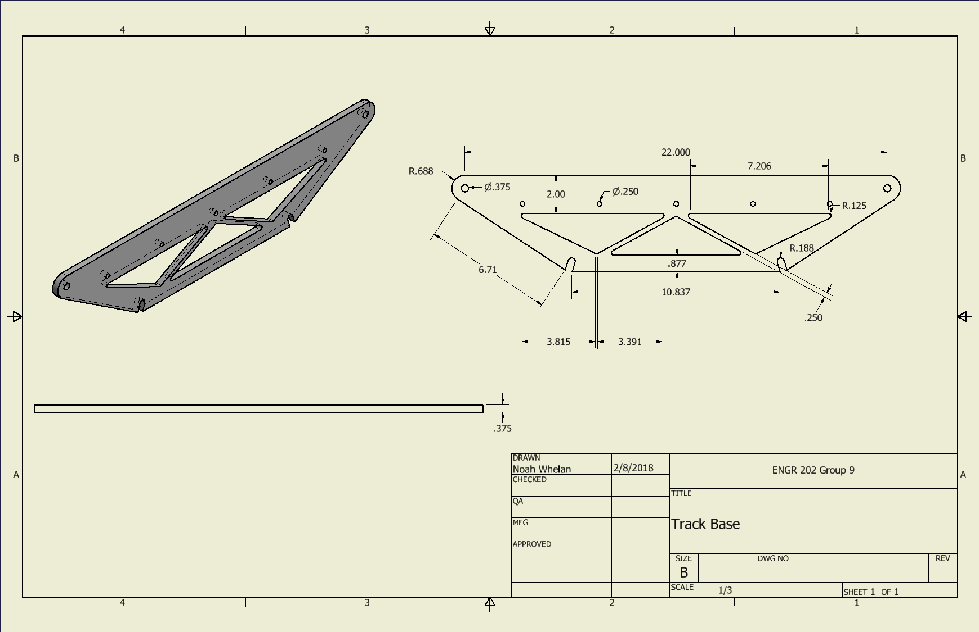

#### Figure 10 - Preliminary Design 3: Track Base

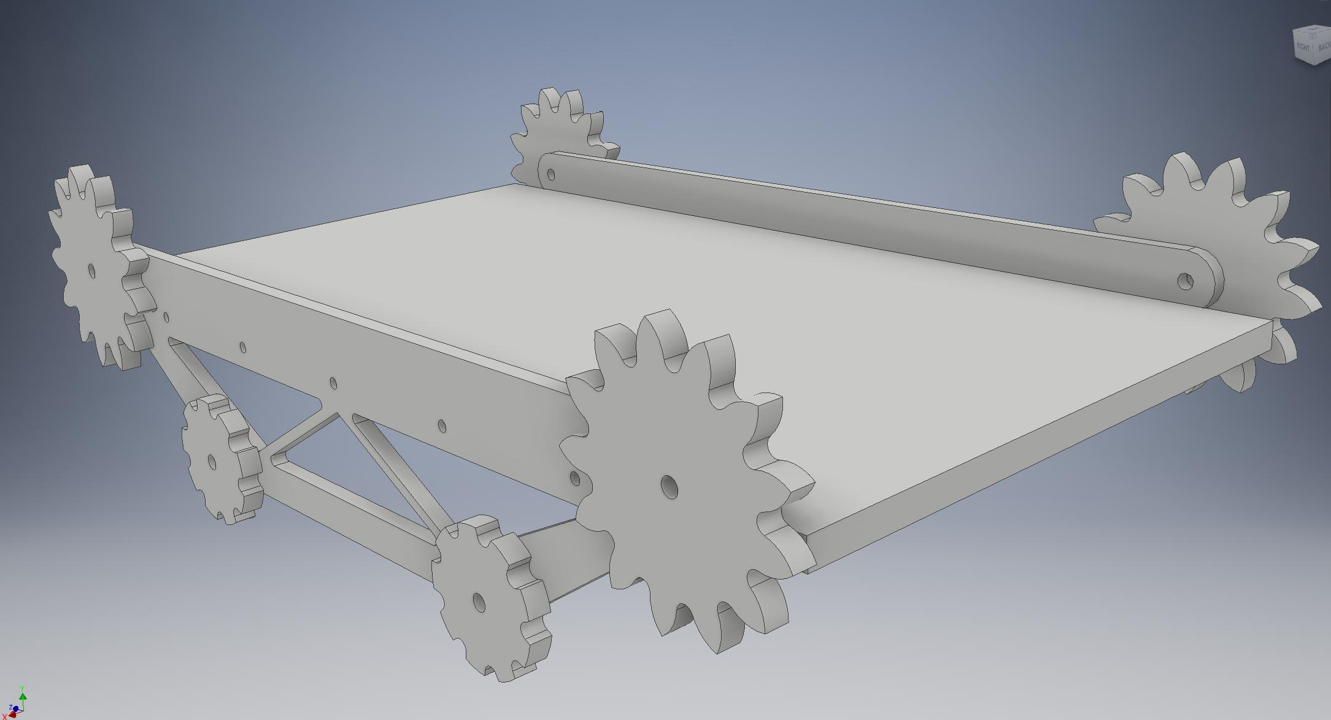

#### Figure 11 - Preliminary Design 4: Isometric View of Parts

The second design *(Figures 8-11)* shows a full track in place of wheels that will provide the main support to climb over stairs. The tracks *(Figures 9-10)* will be attached to the chassis and be powered with gears *(Figure 8)*. The final form of the robot of Design 2 *(Figure 11)* shows that the wheel design, which might fail on stairs without a backing, can be overcome with this particular arrangement of parts. Both designs will be prototyped going forward. The tracks will be powered with 4 motors, one on each corner of the vehicle.

## Updated Bill of Materials

#### Table 3 – Bill of Materials (updated)

# Preliminary Project Design

Electrical System Schematic



*Figure 12 – Breadboard*



## *Figure 13 - Electrical System Schematic*

Technical Drawing

No major changes have been made since the previous Technical Drawing Section. Please refer to Concept Design section “Preliminary Technical Drawings” and figures 5-10 for all technical drawings.

Digital Models

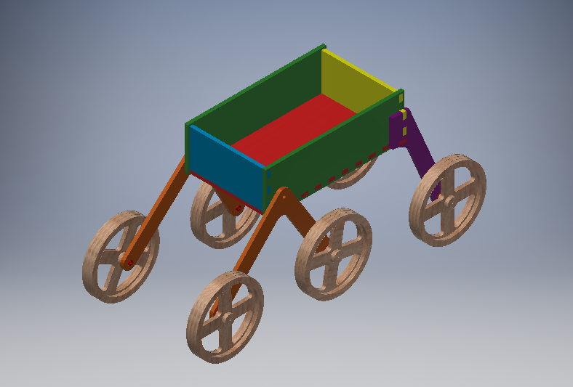

#### Figure 14 - Preliminary Design 5: Isometric View of Parts

Both designs are assembled and can be seen in *Figure 15* for Design 1 and *Figure 11* for Design 2. Design 1 *(Figure 15)* and Design 2 *(Figure 11)* will both take advantage of laser cutting when possible in order to save time and PLA material. This means the panels of the chassis, wheels *(Figure 8)*, supports for drive train *(Figure 8 - 9)* and sprockets *(Figure 9)* will all be laser cut. Smaller pieces, such as the axles in Design 1 *(Figure 15)* and individual tracks on Design 2 *(Figure 11)* will be 3D printed in order to be accurate and be made out of non-wood material.

Both designs use a simple chassis that is a rectangular box in order to conveniently have access to the electronic systems of the robot. In addition, the rectangular box is hollow in order to reduce weight and leave room for the 1.5-kilogram weight that will be carried on board. The drive train will attach to the chassis in order to ensure the robot can be held together. Design 1 *(Figure 16)* takes advantage of wheels in order for the weight to be light and the frame to be rotatable in order to climb stairs. The front wheels are attached in order to maximize surface area contact with the stairs. Each wheel is also independently powered in order to allow “full-wheel drive” and generate torque when the wheels are in contact with any surface. The back wheel does not rotate since having all sets of wheels rotatable will make the robot unstable when climbing over multiple stairs. The back wheel is meant as an extra surface to ensure the robot will not fall backwards. This design will require an additional H-bridge, axles, and two motors in comparison to Design 2 *(Figure 11).*

The files for Design 1 *(Figure 14)* is specifically as follows:

Axel and Wheels

* Axel.ipt
* Front Wheel Base.ipt
* Rear Wheel Base.ipt
* Wheel Inner Ring.ipt
* Wheel Inner Spacer.ipt
* Wheel Main.ipt
* Wheel Outer Right.ipt

Vehicle Panels

* Vehicle Bottom Panel.ipt
* Vehicle Front Panel.ipt
* Vehicle Rear Panel.ipt
* Vehicle Side Panel.ipt

### Axel and Wheels

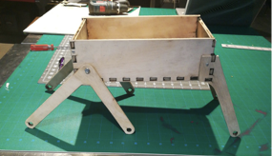

*Figure 15 - Design 1: Prototype Side View*

In addition, a prototype cutout was made for Design 1 *(Figure 15)*. This was cut out of birch wood to show that the design was technically feasible.

Design 2 is still in development, but *Figure 11* shows a mostly completed CAD assembly. Design 2 *(Figure 11)* mainly differs from Design 1 *(Figure 15)* in that it will require more than 6 feet of track as opposed to 6 wheels. The track will be powered by 4 motors (2 on each side) in order to supply enough torque. The traction problem is also solved by having a continuous surface in contact with the stairs, albeit in a less flexible shape than Design 1 *(Figure 15)*. The gear design will also provide greater torque to the robot’s drivetrain since the speed will be reduced. Design 2 will require fewer electronics components (as stated above) but will require more material and potentially stronger motors in order to work.

## Simple Machines

Design 1 *(Figure 15)* features a lever for the front 4 wheels and a wheel and axle for each of its 6 wheels. The second-class lever will get its force from when the wheels apply a force to the stairs and the stairs push back. This will cause the level to rotate around the fulcrum, which is on the robot chassis, and allow the wheels to climb up the stairs and bring the robot with it. This is a simple machine since the force from the stairs pushing back moves the robot, causing work to be done. The wheel and axle machines found on each of the 6 wheels allow a motor to spin each wheel and axle at the same rate in order to cause the robot to drive. The wheel and axle are simple machines on this robot since they apply a force (from the motors) to move the robot and spin themselves. In combination with the lever on the front wheels, the robot will be able to climb stairs since the wheels can move the whole robot and the level will allow the robot to rotate in order to climb stairs.

Design 2 features gears that are used to power the tracks. The tracks will lay into the gears (of two different ratios) in order to supply maximum torque when the robot is climbing up the stairs. Torque is important in order to overcome gravity and climb up the stairs, meaning the gears are designed to be slow but powerful. It is a simple machine because it helps the robot apply a force coming from the motors against the ground in order to do work to get up the stairs.

The main reason there are two designs is so that we can test the functionality of these two simple machines. Design 1 *(Figure 15)* uses more machines in order to increase the surface area and power applied to the surface through its lever and wheels. Design 2 (*Figure 11)* uses gears to provide torque to the track but has a smaller surface area by being unable to rotate. As both designs are tested, there will be much emphasis placed on how the design of the simple machines will affect the robot performance.

# Technical Design Report

## Major Changes

The design that incorporated two independent pairs of rhomboid tank treads was reconsidered due to time and material restraints. Ultimately, the group decided that this design would most likely be too costly and complicated. From there the mechanical team split into two different groups. One of these groups designed a robot that utilized a single pair of large trapezoidal tank treads, with two motors powering each tread. The second team designed a robot that utilized six independently powered and controlled wheels attached to stilts that separate them from the chassis. Two pairs of wheels would be connected together at the front of the robot and would be attached to the chassis via an axle that allowed the wheels to rotate around the surface of the stairs. The rear pair of wheels were rigidly attached to the chassis. When each design had been completed we analyzed them as a team to determine which to pursue. Though it was difficult to tell which would perform better at climbing stairs, our team decided that the production of treads for the tank design would be prohibitively time consuming compared to the wheeled design. In addition, the tracked design would require more power and more weight than the wheeled design, ultimately deciding the wheeled design would lead to a better outcome.

Having agreed upon the wheeled design it was prototyped and tested it. During the design iterations several important changes were made. Our first prototype did not have sufficient power to climb the stairs. To remedy this we first replaced our initial small 9 volt DC motors with similar but much more powerful ones. These new motors were 12 volts and ran at 30 RPM or 100 RPM. Secondly, the second prototype chassis was constructed out of acrylic, as opposed to the wood in the first design. This was done to save weight and reduce the amount of torque needed to pull the robot up the stairs. In our third design iteration we added braces to the two forward axles to reduce flexing that caused the wheels to lock up. In addition, after several of our axles snapped we designed new stronger axles that were able to withstand the stress of going up stairs. Springs were also attached to the front-most section of the robot to pull up the robot after the front wheels ran into a flight of stairs. These major changes are what have allowed the robot to improve from being unable to even move up a slight ramp to reliably climbing stairs.

## New Models and Technical Drawings

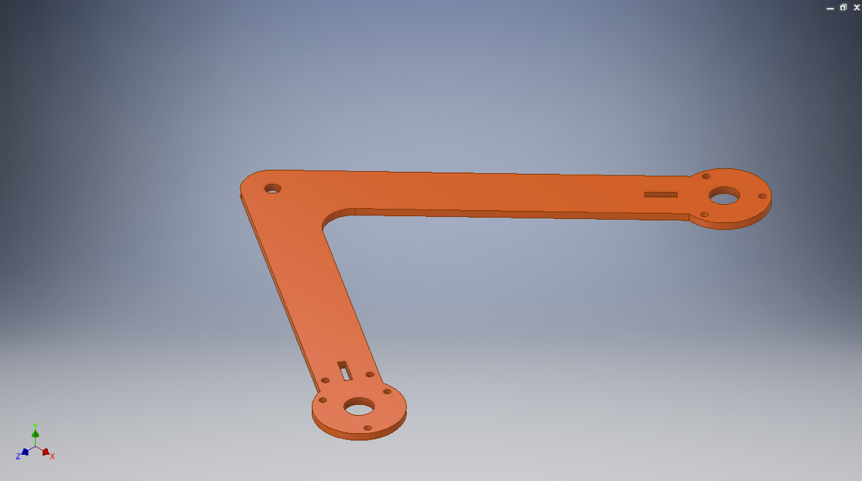

*Figure 16 – Front Wheel Support*

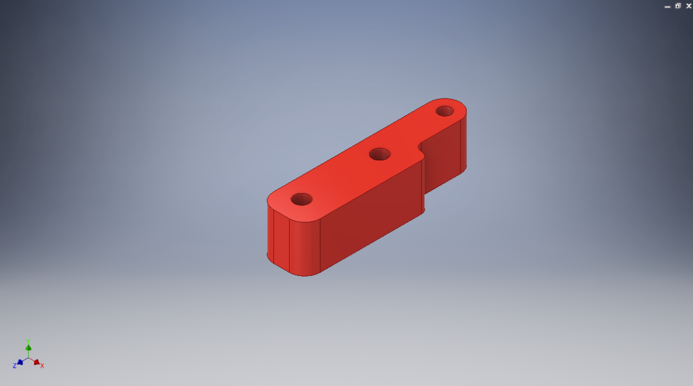

*Figure 17 – Leg Stop*

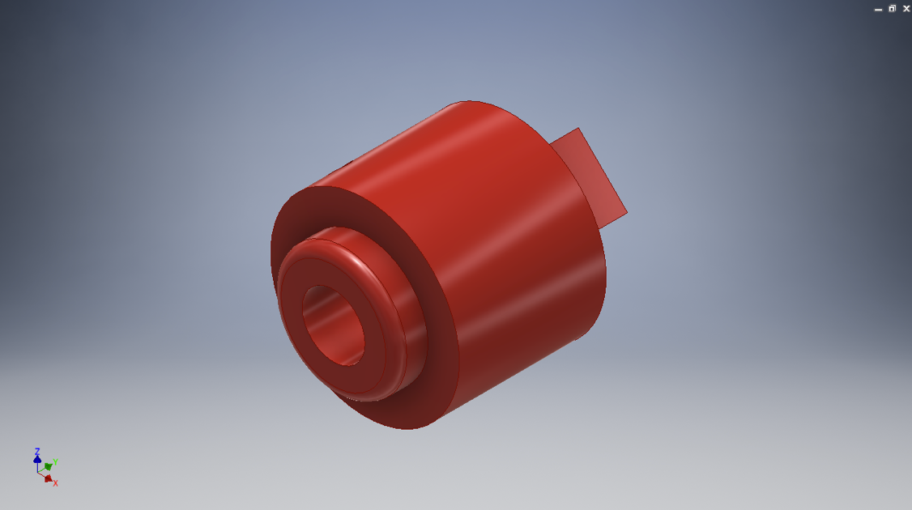

*Figure 18 – Motor Axel*

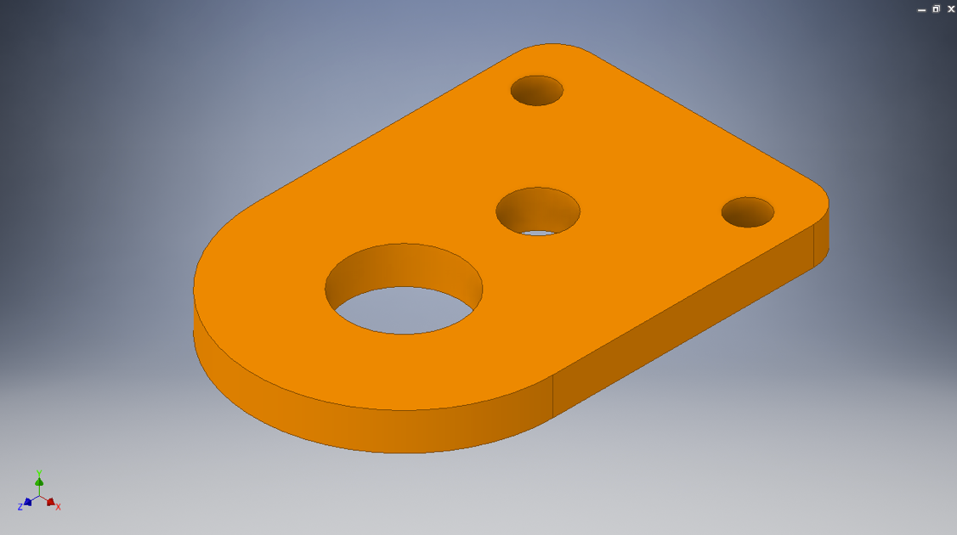

*Figure 19 – Motor Mount Plate*

#### 

*Figure 20 – Motor Mount*

#### 

*Figure 21 – Rear Wheel Support*

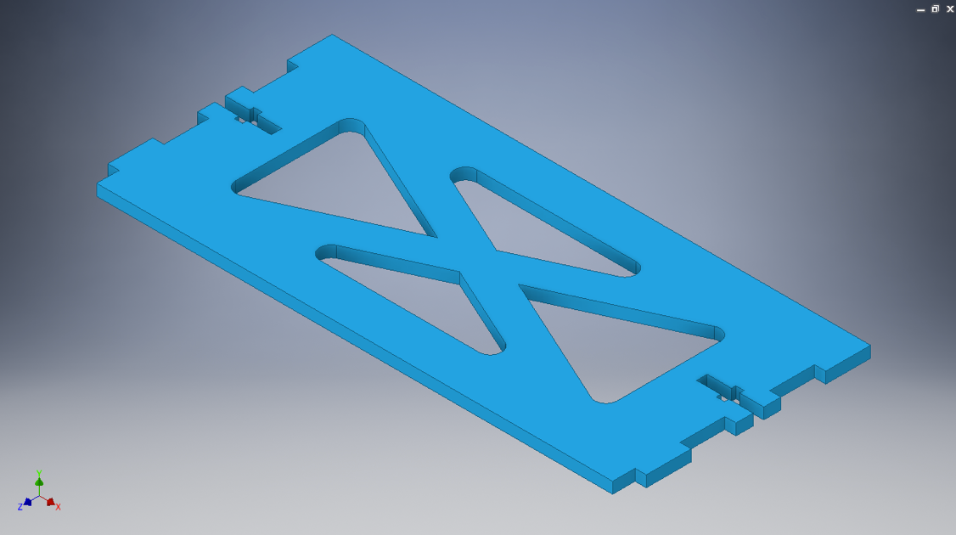

*Figure 22 – Vehicle Body Front*

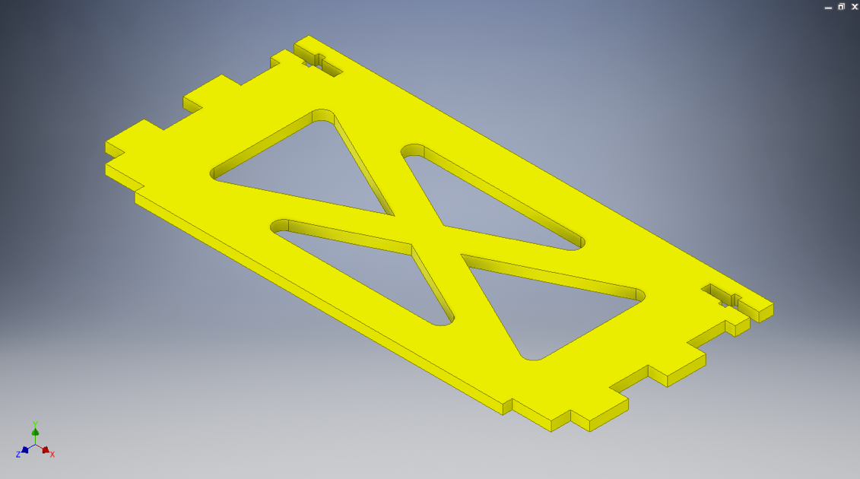

*Figure 23 – Vehicle Body Rear*

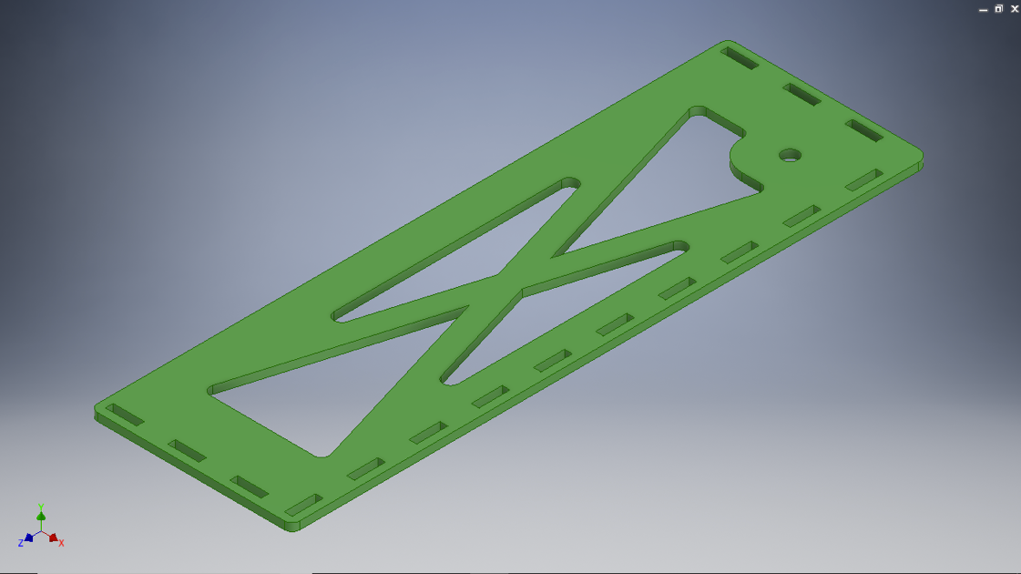

*Figure 24 – Vehicle Body Side*

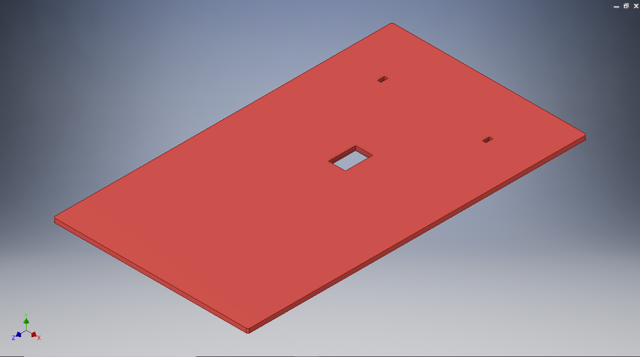

*Figure 25 – Vehicle Body Top*

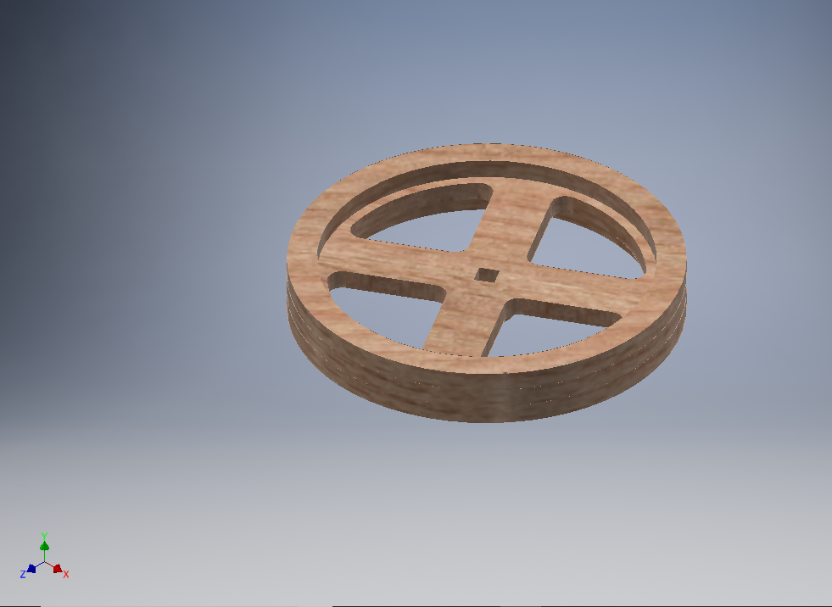

*Figure 26 – Wheel Main*

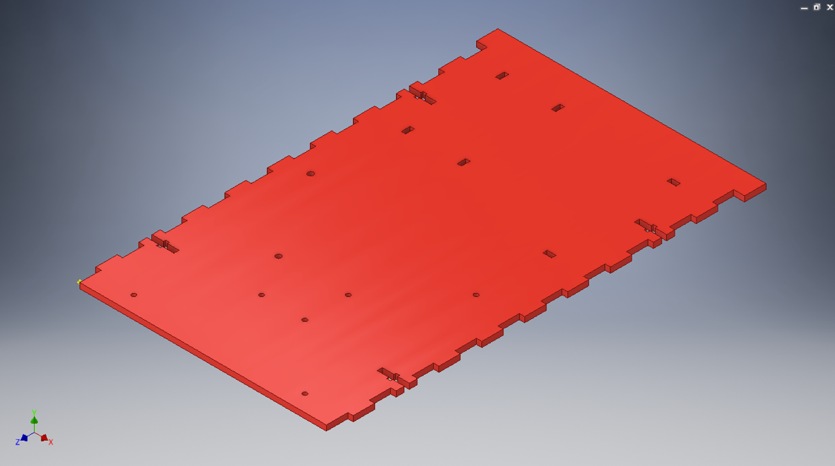

*Figure 27 – Vehicle Body Bottom*

## Final Design

## C:\Users\Aaron\AppData\Local\Microsoft\Windows\INetCache\Content.Word\IMG-0752.jpg

*Figure 27 – Finished Design*

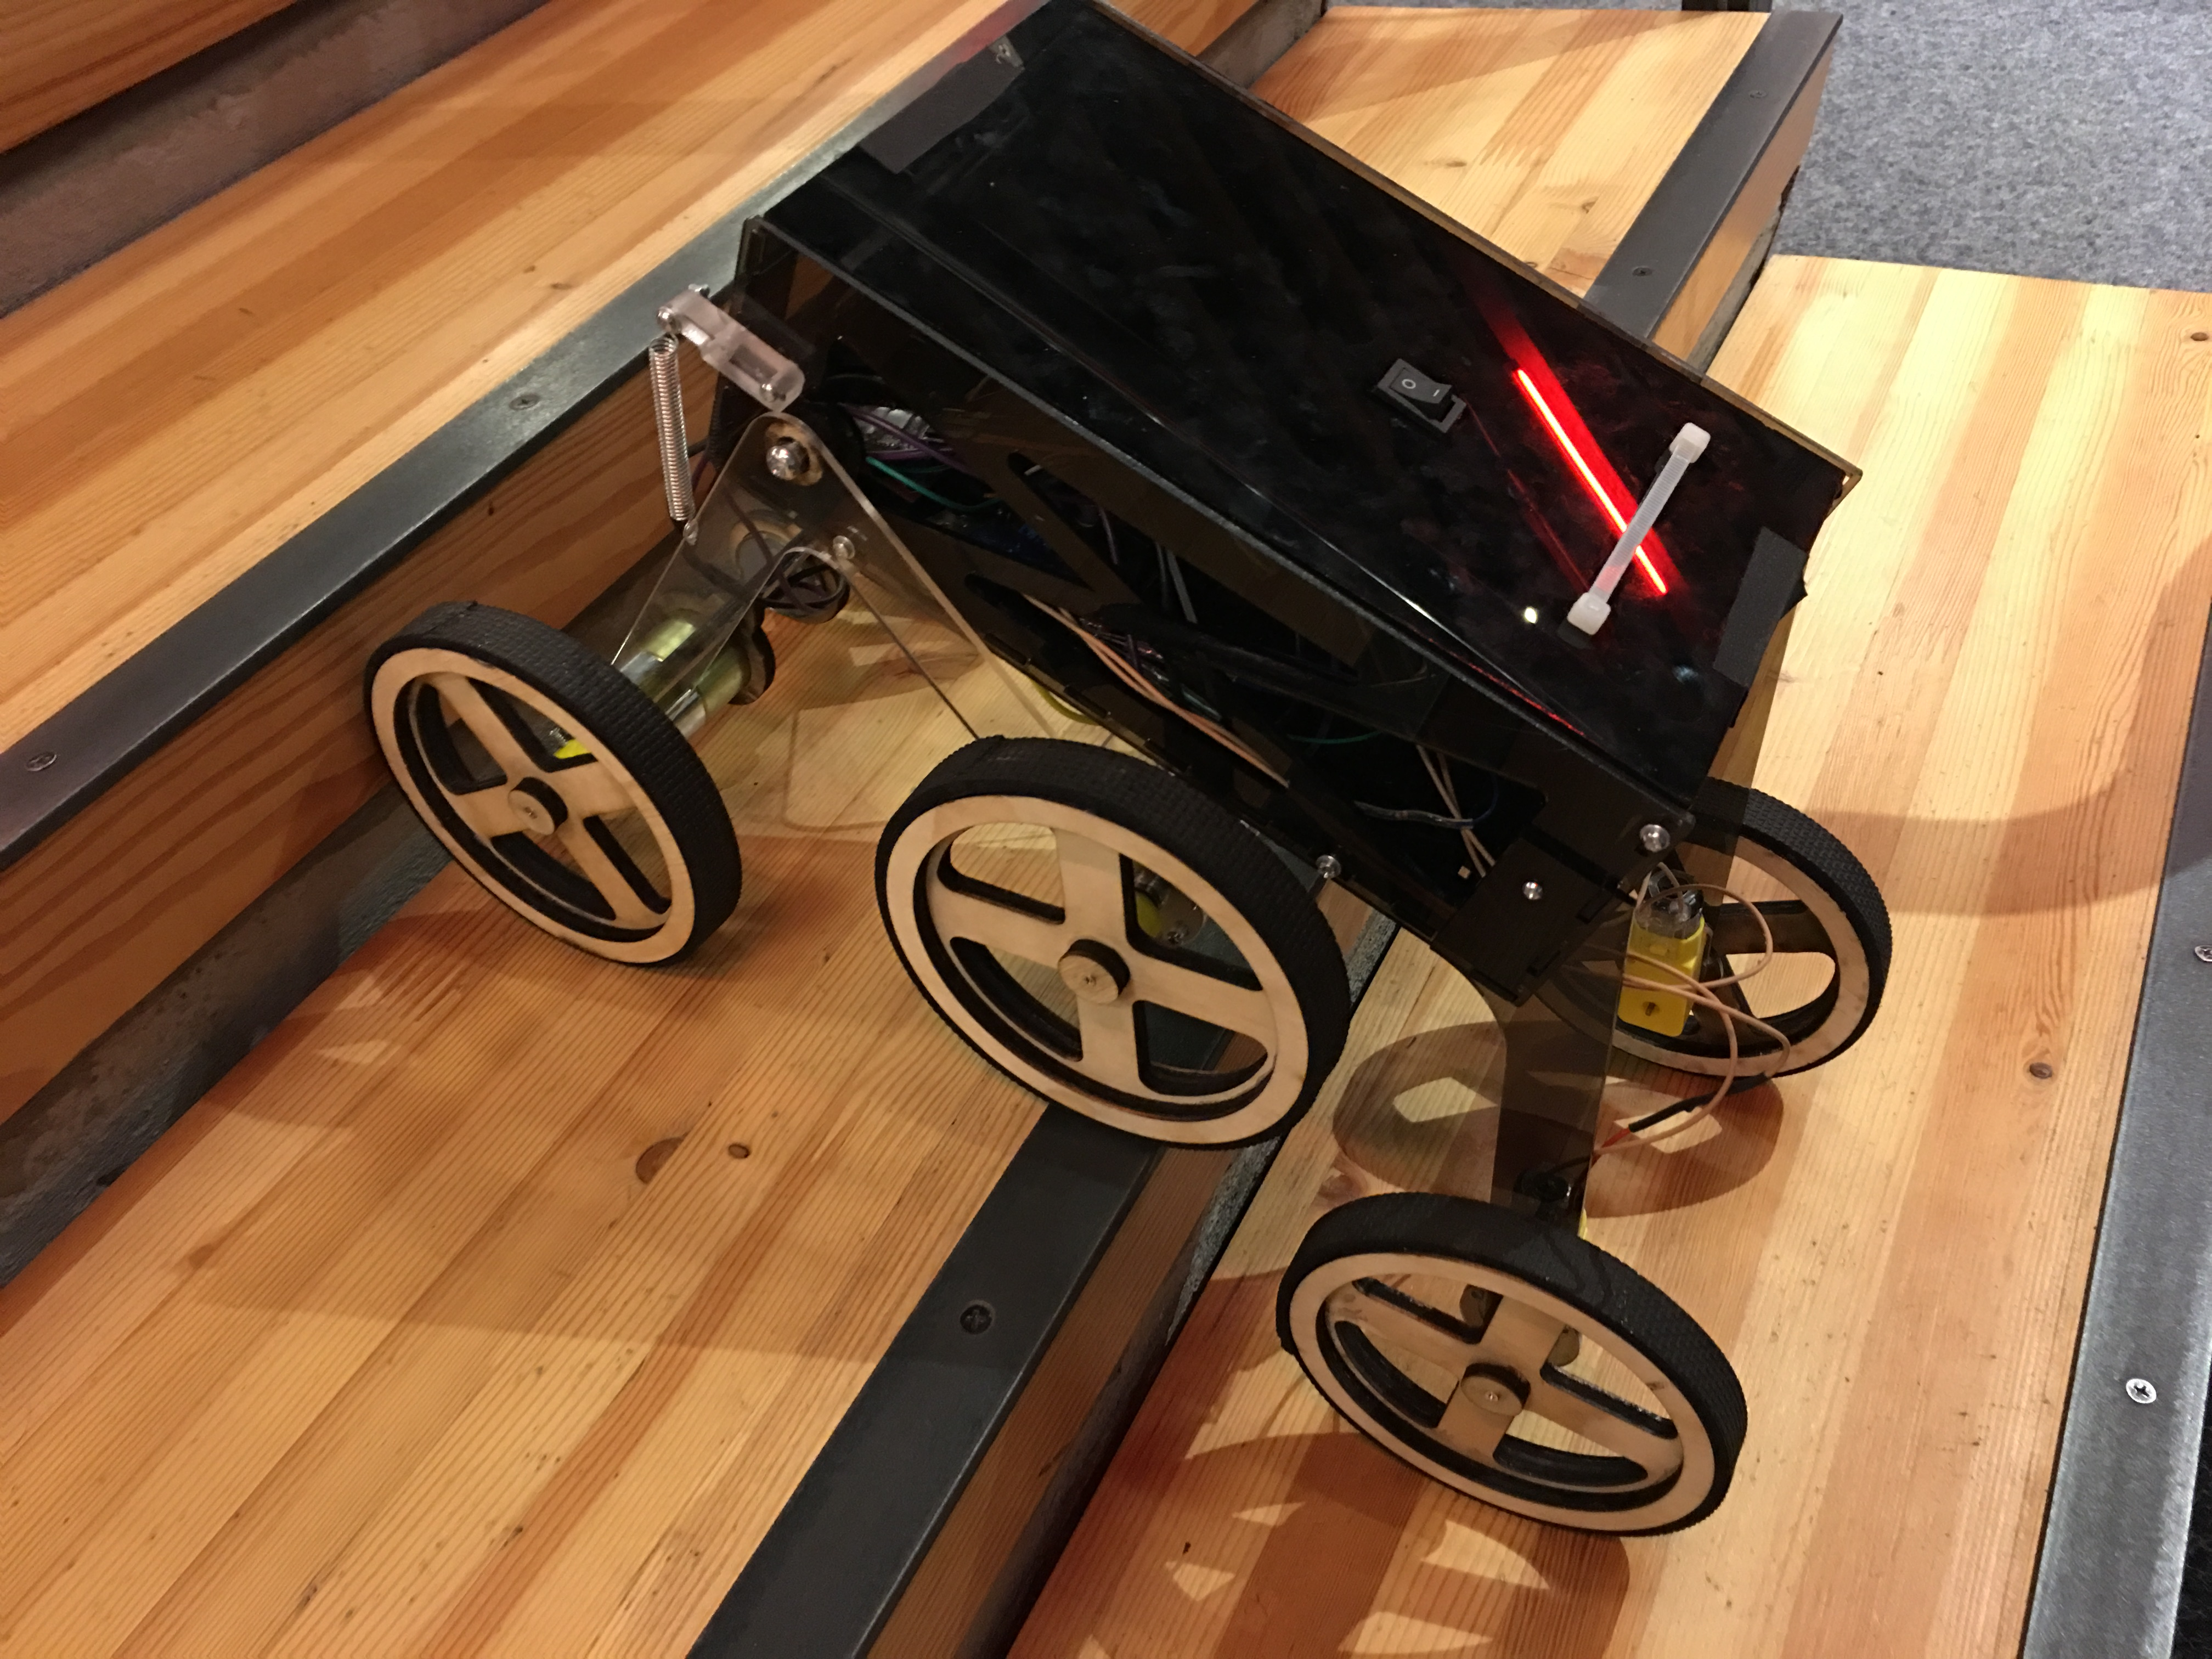

*Figure 28 – Finished Design on Stairs*

## C:\Users\Aaron\AppData\Local\Microsoft\Windows\INetCache\Content.Word\IMG-0755.jpg

*Figure 29 – Front View on Stairs*

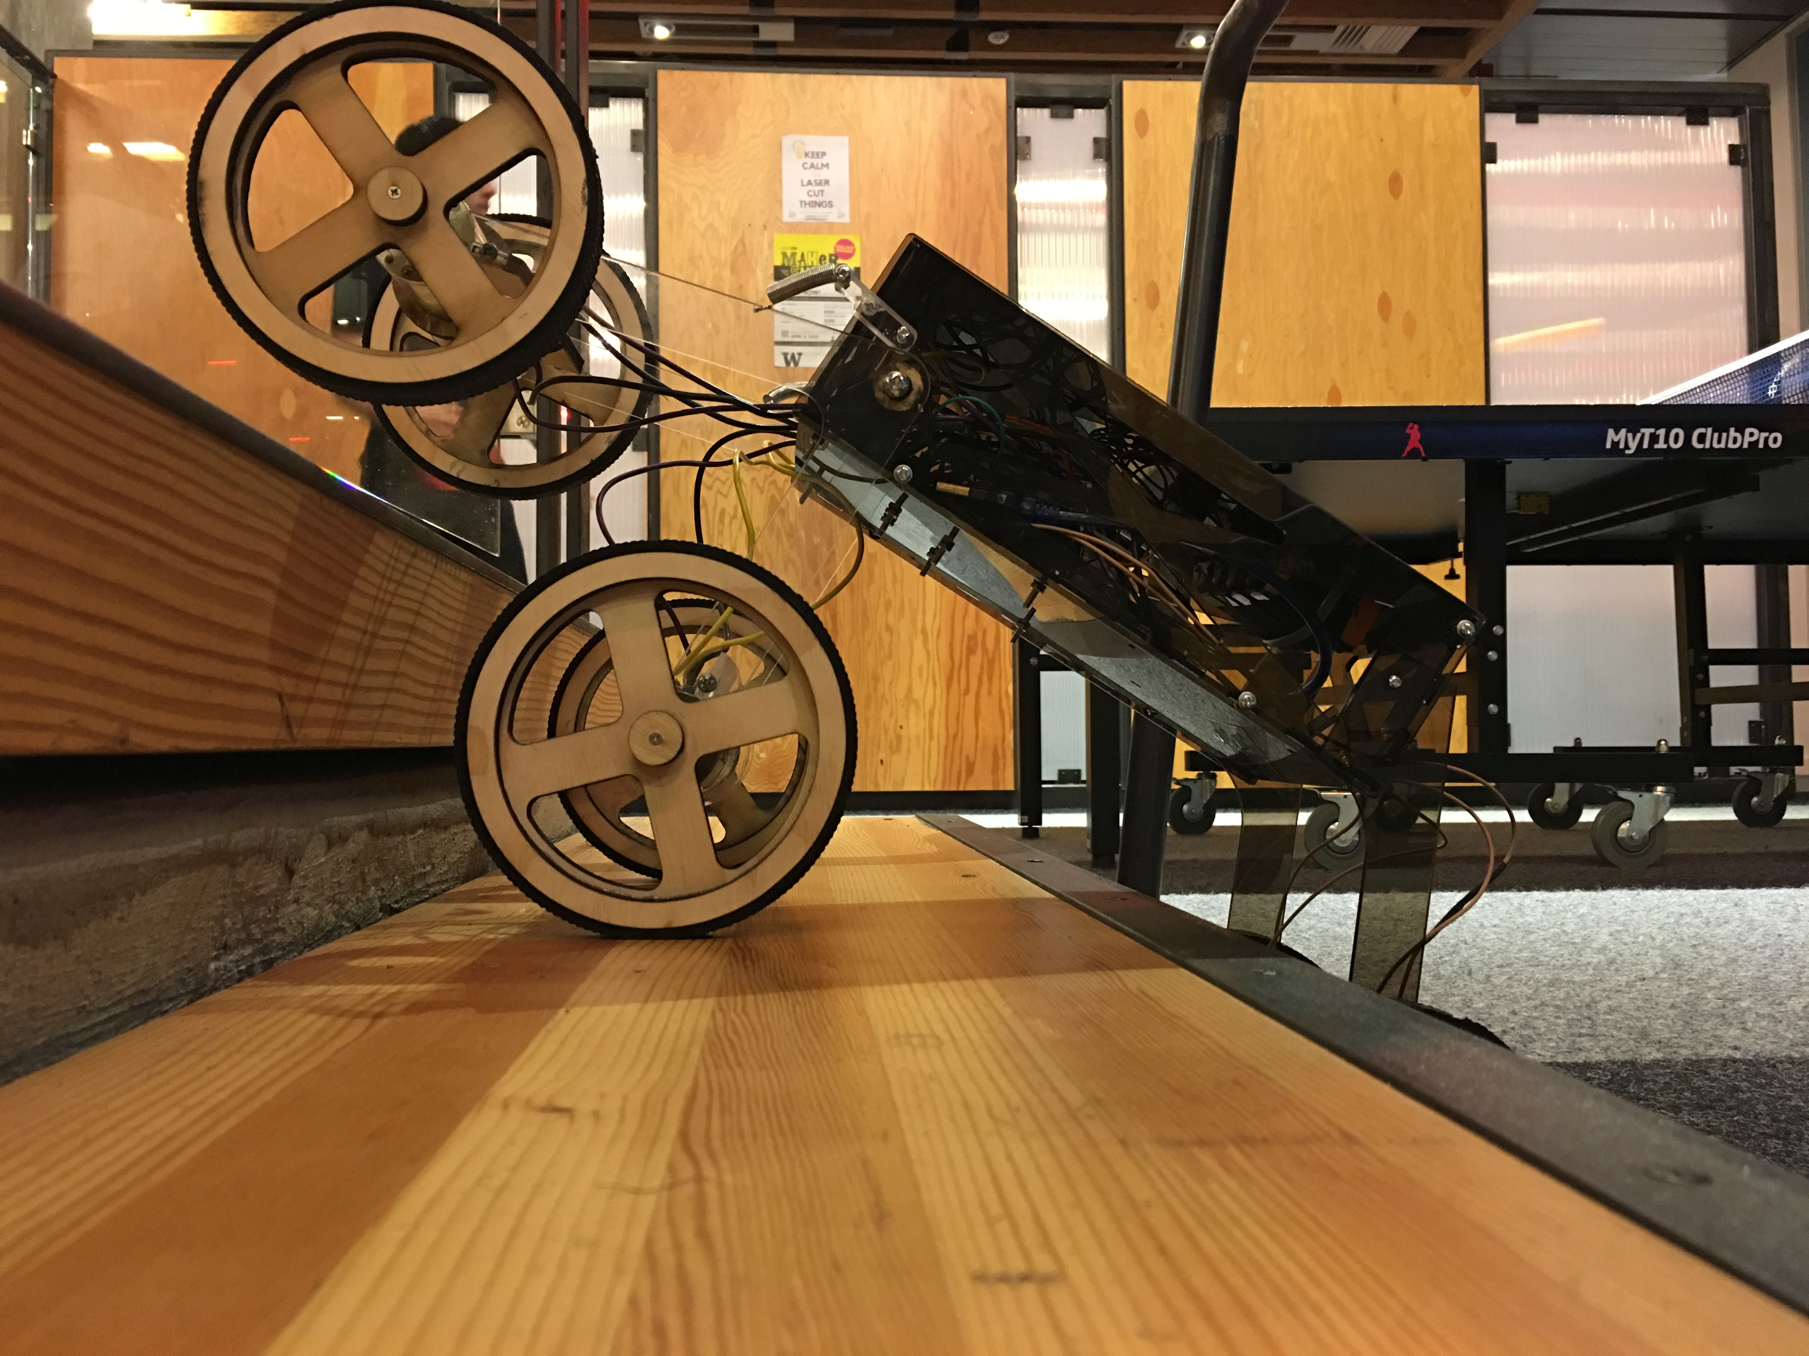

*Figure 30 – Side View on Stairs*

## Challenges Faced

Some of the primary challenges we faced during the creation of the robot arose due to monetary and time constraints. In the process of designing our robot we considered multiple designs that incorporated a continuous track or tread. The most time efficient way of creating such a robot would have been to purchase a manufactured tread or belt, 3D printed tracks would have taken too long to print and assemble. Unfortunately we could find no belts of appropriate specifications that would left room in our budget for other important components. Had we the time to print all the necessary track or the money to purchase tread we could have more seriously considered using a tracked robot. Other obstacles also increased the challenge that time posed. One example of this was our reliance on the Dabble Lab. Several times throughout our build process equipment failure meant we would lose a day of work time. Conflicting schedules meant we could often only meet a couple times in a week, meaning a delay of just a day could put us more than half a week behind.

Overcoming these challenges meant adapting our design methods and time management. During our initial design phase we had to take a close look at the feasibility of each proposed design. While the tracked design certainly had its benefits over some of the others, ultimately we determined it to be an unrealistic design path. For all its pros it was simply too time consuming to pursue. To save resources and time we stopped our prototyping of tracked designs and put all our effort into producing a functioning prototype that used wheels. Doing this allowed us to fast track our primary design while minimizing waste on designs we couldn’t reasonable build. Time management was also vital in keeping our team on track to complete the robot within the set time constraints. We began to anticipate the possibility of equipment failure. When we planned work sessions we would often set a backup time in the event we couldn’t use the required equipment for progress. We also extended the length of our work sessions to make up for time we had lost previously and to negate the effect of future delays. By proactively responding to these obstacles we have been able to complete our robot on time and within budget.

## Reflections

Reflection 1

**1). What major are you pursuing, and what got you interested in that topic?**

I’m pursuing two majors with two degrees: Informatics and Anthropology. I’ve found my interest in creating things since I was very young. I made my parents holiday presents by hands every year. I started my design journey at making mini wood crafts at the age of 6. At that time, I thought I would be an architect in the future. However, my design interest in building real construction was killed in my first semester of high school by the fact that I did not enjoy physics. But I still enjoy the design process. So I moved on to another field of design, chemical engineering, and bioengineering, hoping to design some new formulas. My second try failed quickly after two semesters of labs. It was partially because I didn’t get to talk to many living creatures, as known as people, and I didn’t feel the lab environment was encouraging creativity. Luckily, my third shoot worked out. After two semesters of “social isolation,” I started researching different modern social networking mobile applications and computer software. I then found that although those apps had the same purpose of communication, their design made my user experience very different. I then did more study on the idea behind those designs. This is the moment that I knew where to place my design enthusiasm. However, I still felt like my puzzle was incomplete. I found the missing piece from an Anthropology class where we discussed the human nature, such as value. I always believe that good design helps to improve our living quality through unconsciously introducing it’s embodied values. And my interest is to become a good designer who can do good designs with good values. So my current interest is in HCI, information architecture and information assurance and cybersecurity, as well as what is the role of technology in globalization and how does it help shift human’s culture. – Rhea

I am pursuing a major in mechanical engineering. I can’t remember when I decided on

specifically mechanical, but I have always been interested in engineering of some sort or

another. In the middle of high school, I decided that I wanted to become an astronaut, so I was

going to study aeronautical engineering. Then later on, I had a change of heart, when I realized

that it would be much better to try and fix the issues on our own planet. From that point, I was

really interested in biomimicry and how it can combine with engineering and architecture.

Now, I am interested in pursuing robotics, as I have just had that avenue opened up to me and

it is really exciting, as unfortunately my high school never offered any robotics, so I am having

to make up for lost time. - Caelen

I am majoring in Computer Science and Engineering. In high school I took a web design class and got introduced into web programming, and from there I started to learn other programming languages and joined different engineering clubs. I enjoy working on computers, since they are accessible, powerful, and it doesn’t “cost” anything to write code. - Aaron

**2). What do you think working as an engineer means?**

Engineers are designers who focus on designing practical solutions. So engineers are just like designers— they can work in various fields. I think working as an engineer means that I’m only a part of the project team and I need to learn how to collaborate and communicate to achieve the design goal. An engineer should be able to analyze, design, develop, test, and evaluate the design object with creativity. However, I think engineers usually focus more on improving and maintaining the current system than on building something new from nothing. I think each engineer is responsible for being creative and realistic on each design project to make sure the design has a practical use. I think engineers are meant to perceive the world underlying mathematical and mechanistic basis, and remodel the world using quantitative tools. Engineers should know some science and have the ability to draw connections between science and the practical use. Engineers are ambassadors who bridge science and everyday life by applying science to design. And those applications of science in engineering can later help advance science. Engineers are craftsmen who realize their ability and potential in solving problems in different field such as healthcare, transportation, food, education, communication, and the environment. I think scientists focus on finding the fact of the reality, while engineers are dedicated to building new reality based on current reality, and they ultimately make this world a better place together. - Rhea

I think that being an engineer is being someone who can be presented with a problem,

whatever their specific field is, and using creativity and scientific knowledge to find a solution

for it. It means working with a team to create a completed product or project. - Caelan

Working as an engineer means applying skills and knowledge to solve a problem, as well as learning new skills and obtaining knowledge as you work. From engineers I have talked to, they always strove to gain hands-on experience and learn skills as they work on projects or solve problems. Engineers also have to be willing to admit when they don’t know a certain topic and have the attitude that they will learn as much as they can about a topic. – Aaron

**3). What are the most important skills for an engineer to have?**

I think the first important skills for an engineer to have is communication skill. Based on scientific research, creativity is the innovative outcome of a collective community. According to my observation, an engineering project usually has a big team but still takes a long time to finish. Although prototyping reduces some cost in the engineering design process, inefficient team communication can promise a smoother collaboration experience. So I think the ability to work as part of a team is essential for an engineer. The prerequisite for being an engineer is having a solid foundation of knowledge in STEM fields at a certain degree level, such as a master degree. So I think having a qualification in STEM subjects can endorse an engineer’s problem-solving skill in solving mathematical and logistical problems. It would also be great if an engineer has a strong analytical skill so that the solution can be developed at a lower risk of failure. I believe one’s analytical skill can be built out of quantity, as being said, “quantity makes quality.” Since engineering projects are usually very complex, it’s good if engineers can always pay attention to details during planning, designing, and construction processes. I think attention and sensitivity to detail is one important skill for an engineer to have for reducing the chance of project abortion. Additionally, I believe a good engineer should also have excellent communication skills in using technical terms in at least one language, and be able to talk to people with different knowledge background, such as clients. - Rhea

First and foremost, creativity. An engineer, of any field, needs to be able to think outside of the

box, they need to be able to look at the problem from many different points of view. Secondly,

they need to have a good understanding of scientific principles relating to their field. - Caelen

The most important skills for an engineer are teamwork and desire to learn. Engineers will not be experts in everything required to solve a problem, so they need to be able to work with other people who know more about another topic than they do. Engineers also need to be able to lead the project forward with their own knowledge. While the team is working together, engineers should also want to learn from each other in order to improve their own knowledge and understanding so that they can be successful in future engineering projects. – Aaron

**4). What do you hope to get out of this class?**

Learn how to communicate with engineers and also learn some skill. Be empathy instead of sympathy. Since anything working environment requires team communication and collaboration skills, I want to practice my skills in the engineering environment. I want to practice my skills in professional planning, communicating, and collaboration with engineers. I want to better understand what and how engineers think and build empathy with them. So I want to pick up some practical engineering skills which can allow me to prototype my idea in new ways. I want to learn the newest technology in the industry such as using CAD software, 3D printer and Laser cutter for prototyping. I also want to learn more project management skills and apply them to everyday life and my future projects. For example, I already applied Gannt chart at managing my school schedule and moving plan. I believe this class can help me build much more other basic skills that are often ignored but essential for my future career development. In the meantime, I want to practice my knowledge from other fields in engineering. For example, I can practice my design thinking skill from designing information system. By taking this intro engineering class, I can see how I feel truly feel about engineering at the age of 20. Moreover, I want to make friends at different ages with diverse backgrounds. – Rhea

I hope to enjoy myself in this class, I want to make sure that I’m not overly romanticizing what

being an engineer is, but I don’t think I am. I think an important part of this class will definitely

be working as a cohesive team, not only so that our project succeeds, but also so that we all

have a good time in this class. – Caelen

I hope to learn skills that are related to fields of engineering outside my major. This includes mostly electrical circuits, CAD modeling, 3D printing, and laser cutting. I don’t want my education to be one-dimensional (only learning programming) so I feel it is important I take this class in order to introduce me to ways I can become a more well-rounded engineer. – Aaron

Reflection 2

**1). What do you think will be your greatest challenges in working on this project and why?**

Stay positive is my greatest challenges in working on this project. I am not an expertise in the domain of our “stair-climbing robot” project, so I’m afraid to give feedback, ask questions and share my idea. Also, it’s a challenge for me to stay positive while the team has a negative patter, “Yes, looks good.” The challenge here for me is that I will be discourage if I will not be the one who is still willing to share ideas while having no feedback. Also, asking question in the domain that I’m not very good at makes me feel extremely uncomfortable. It’s a challenge for me to keep motivated for what I’m learning. Since this class is an intro class, I’m afraid that my teammates are not taking it seriously. I’m very sensitive to the environment and I will also lose my interest in the class, and therefore will not do as great as I wish. Also, staying positive is even harder when I don’t know my teammates that well. All in all, that’s why I thinking keeping a positive is my greatest challenge in this class. - Rhea

One of the greatest challenges that I have been facing is working well as a team with all of the members. Most of the team I can work with well, but there are a couple that I am having a hard

time working with. Some of the issue arises from both sides being stubborn and not fully listening to each other. - Caelen

My greatest challenge will be finding ways to get everyone to contribute as well as balancing my contributions in this class with my other classes.  Time is getting more and more precious and limited, so we need to make sure the project is finished on time. Not only that, we have to make sure everyone in the group is learning and contributing, as otherwise the group will not work well. - Aaron

The greatest challenge for this project will clearly be that the robot is able to climb up a set of stairs. The main problem in this area is to enable the robot to push itself up the stairs without its contact points slipping down. This is the greatest challenge because if the robot slips down the stairs, then it would never be able to move up a set of stairs. - Valentina

**2). What steps are you going to take to ensure that you will be successful in this class?**

Try to add be not afraid of asking stupid questions even if I don’t know too much about those physics concepts. Even if when I don’t know how to phrase my question due to the language barrier, I should still ask as many questions as I can in order to understand the problem statement correctly and therefore engaging in project deeply. Getting my hands dirty is the second thing I will do. I will try to prototype more. I have learned that prototype is not meant to be perfect, and it is the best way in the design process to find out if a design idea works. Even if the prototype has the lowest fidelity, I should still externalize my idea into a prototype. Additionally, I will communicate well with my teammates to make sure we are on the same page. I will try to make my problem statement as clear as possible, and ask explicit questions, for example, “I am not aiming at solving the problem of ….” I will try to critique as much as I can with valuable feedback. – Rhea

I endeavor to maintain a good team mentality, and make sure that I do my best to listen to all

sides of an argument. I try my best to offer as much constructive criticism as possible. Also, I

have been making sure that I do my share of the work and do everything that I say that I will in

a timely manner. – Caelen

I am trying to balance my workload with other classes in order to make sure I can contribute to my group’s project. This also means researching things on my own and spending time outside of class improving my engineering skills. I am also trying to teach what I already know to the rest of my group in order to incorporate them more. Finally, I am trying to talk to course staff more, and I believe they have helped me become better engineers. – Aaron

Put more effort in my involvement in the design process. I don’t particularly know much about programming and CAD design, however we have learned the basics during class, so in oder to contribute on the success of this project I will take time outside classes and the lab times to practice on my own programming and OnShape design. I would also ask for help whenever I need. There are a lot of skillful members in my group and they are always available to help and explain how to do something. – Valentina

**3). Teamwork is a very important skill for engineers, you will rarely be working on a project alone. What steps are you taking to ensure your team as a whole will be successful?**

Communication is the most important part in the team work. I will take the role of a facilitator to make sure the communication of idea is going smoothly throughout the project. I will also learn how to use professional project management tools to help us better manage the overall project. I will be specific in the communication process and try to make professional statement. I will help assign the work fairly and everyone stays happy. Also, I will make sure everyone’s on the same page so that we are aiming for a same goal. This means, everyone understand the problem statement correctly, and then critique on the solution idea. I will schedule a weekly critique for our group so that our team have a block of two hours outside the class meeting, and give valuable feedback. I hope I can be the one who introduces a positive pattern in the team. - Rhea

Communication is key, making sure that all of the team is informed as to what our plans are,

what everyone’s jobs are and when are key deadlines. Also, making sure that each member is

given projects that they can do, both based on their skills and time availability. Also, it is very

important to make sure that the criticisms that you give are constructive, as it is a team and you

want everyone to succeed together. - Caelen

I am making sure that the team is fully involved, engaged, and up to date on what needs to get down. I also try to make sure team members are playing to their strengths while letting them experiment with things outside of their comfort zone. Ultimately, I am trying to keep everyone on track while also making the project fun and educational. - Aaron

Create an environment in which people feel comfortable taking reasonable risks in communication and defending their position even when is not the common one.

Practice 'Participatory Leadership': assigning tasks, evaluating progress, and offering guidelines for the team to function as a whole.

Each member is committed to get the best out of himself, to put all their effort to get the job done. The commitment of the group makes it happen to a high performance team where the sum of the parts multiplies. - Valentina

Reflection 3

**1). What have been your greatest challenges so far working on this project?**

Trying to apply my limited physics knowledge on the mechanical part of the project has been one of my greatest challenges. Since I haven’t touched physics for at least two years, it’s been a hard time for me to pick up that memory and apply that knowledge while connecting those circuits. The problem becomes even more challenging when I realized the gap between the ideal circuit graph and the actual position on the breadboard. – Rhea

One of the biggest challenges was getting the team to all work together, as for a long while

there were two different designs in our group. Luckily our group finally settled on one design

and so we are now a united front. - Caelen

The greatest challenges so far is overcoming our weaknesses, primarily the team’s lack of knowledge about circuits. The electrical team has done a lot of work to learn electronics, but we still do not see the same progress the mechanical team has. Other than that, building our working prototype has been difficult since we are unsure of how the design will work. – Aaron

For our project the greatest to challenges have been deciding whether the want wheels or tracks in our robot, and the electrical and circuit part. The first challenge revolves around which one is better for the task of moving up stairs. The second challenge I thinks is the greatest because our schematic is very complex and we need to put to work 6 motors, and these are our only parts. We have a lot of parts so it will be very hard to install them. - Valentina

**2). Has completing your project been more or less challenging than you expected? Why?**

The project goes pretty well so far and has been less challenging than I expected. I expected the Arduino part and the electrical part would be very hard for me to understand the concept. However, I found that Arduino coding is fairly intuitive and manageable for me to handle it. So I might be able to implement the Bluetooth remote control at the end of the project. – Rhea

Completing my section of the project has been just as challenging as I expected it to be, after I

changed my design from a tracked robot to a wheeled robot. I was initially really surprised by

how hard it was to create a system of tracks. - Caelen

Completing the project has gone pretty much how I expected, since I had prior experience with robotics and know generally what the process was like. Prototyping has been a little slow, but that is acceptable since we still have time left. That being said, I was unsure how everyone on the team would work together, and I was surprised that we have worked well as a team. I also thought the mechanical part of the design would be challenging, but two members of the team know CAD very well. So, I would say completing the project has gone fairly well overall. - Aaron

In general printing and laser cutting the parts has not been challenging at all. However I believe that the most challenging part of the whole project is the electronics. I was definitely harder that I expected it was going to be and is visible on the schematic. There are a lot components and interconnections in the circuit and we need to be careful the we don’t make any mistakes that may affect the robots ability to move around. - Valentina

**3). Do you think the goals you set for your project in your proposal are still realistically achievable? Why or why not?**

I think the goals I set for my team project in the proposal are still realistically achievable because our goals are set on a feasible conditional which gives us time to focus on our main goal. The mechanical team has made great progress in prototyping our robot. I have enough confidence in our robot successfully climbing up stairs in Area 01 with wireless control. – Rhea

Most of the goals that we set for our project are still achievable, the one that I am not sure of

right now is to carry a 1 kg weight up the stairs. As of right now I don’t know if this will be

possible, as the motors might not be able to push it up the stairs. - Caelen

The goals we set are still realistically achievable, with the exception of climbing the chosen set of stairs. We should still be able to drive on a flight or inclined surface as well as carry an additional weight. The main challenge will be climbing our chosen flight of stairs given the size of our wheels. This may force us to change our goals and instead choose a shallower set of stairs. We will not know this until we prototype however. - Aaron

In my opinion the goals set by our team are achievable. We set goals that at our reach and that easy enough to be achievable but hard enough to challenge us. They are realistically achievable because we adapted them to what we have at our reach, we are going to focus on only a set of stairs for the start of the project, however we hope it could be applied to any other type of stairs, we are also making sure that our project works in a specific environment so that then it could be modified to a different one. - Valentina

**4). What skills or information do you need to help you finish your project?**

I need to self-learn more Arduino commends in order to give our robot the ability to complete more tasks. Also, I need the knowledge of troubleshooting the problems that might occur in our future prototype testing. The last skill that I might want to for completing this project is how to utilize those machines in making our robot looks nicer than it's current look. – Rhea

As of right now, most of the skills that we need have already been addressed. Moving forwards,

we will be finishing the full assembly of the vehicle and working on making sure the code works

to properly drive the vehicle upstairs. – Caelen

We need to build a bluetooth application and figure out how to communicate over bluetooth with our robot. We also need to start prototyping to see if we can overcome our chosen flight of stairs or perhaps choose to build our own. Other than that, some softer skills we will need are to just stay motivated and keep our teamwork up. - Aaron

Because our robot will be controlled by bluetooth, we need more information in how to configure it. It is not hard, however we need to know how to do it correctly to ensure that it will work. It is also necessary more help on how to install all the electronic parts of the robot. Because it is a very complex project in that specific area, it is necessary more skills. - Valentina

# Reference

* Sharma G. (2009, May 23). *Conveyor belt based sorting machine object size detection east chandigarh*. Retrieved 12 March 2018 from https://www.youtube.com/watch?v=ThhZDGRrlLs.
* UPHIGH Productions. (2016, May 02). *Robot Kitchen - Behold The Future*. Retrieved 11 March 2018 from: http://www.youtube.com/watch?v=rNcPVvIs_tk.
* NBC News. (2017, January 04). *Introducing Kuri, The Home Robot*. Retrieved 11 March 2018 from: https://www.youtube.com/watch?v=QsxmZPRhlsc.
* FarmBot.io (2016, June 30) *Introducing FarmBot Genesis*. Retrieved 11 March 2018 from: https://www.youtube.com/watch?v=8r0CiLBM1o8
* Transcend Tactical (2017, Nov). *Introducing the first hassel-free Tactical Robot.* (n.d.). Retrieved 11 March 2018 from: https://transcend.ai/business-units/public-safety/law-enforcement/
* *Automation and Control Technology Final Year Project*. (2014). *YouTube*. Retrieved 11 March 2018, from <https://www.youtube.com/watch?v=Q1lf14W2sSE>
* *Base of Support*. (2017). *Physiopedia*. Retrieved 12 March 2018, from <https://www.physio-pedia.com/Base_of_Support>
* *Continuous Tank Treads by whowhatwhere*. (2010). *Thingiverse.com*. Retrieved 12 March 2018, from <https://www.thingiverse.com/thing:2820>
* *Friction and Friction Coefficients*. *Engineeringtoolbox.com*. Retrieved 12 March 2018, from <https://www.engineeringtoolbox.com/friction-coefficients-d_778.html>
* Gupta, R. (2015). *STAIR CLIMBING ROBOT*. *researchgate.net*. Retrieved 12 March 2018, from <https://www.researchgate.net/publication/303549760_STAIR_CLIMBING_ROBOT>
* Heriot-Watt EPS Mechanical Engineering (2011)*, Stair climbing Robot Shrimp 2011*. *YouTube*. Retrieved 12 March 2018, from <https://www.youtube.com/watch?v=4QDJWIUDSEk>
* Robotpark ACADEMY (2013). *How to Design a STAIR CLIMBING ROBOT 81004 - Robotpark ACADEMY*. Retrieved 12 March 2018, from <http://www.robotpark.com/academy/how-to-design-a-stair-climbing-robot-81004/>
* Lucidarme, P. (2008). *B2P2 robot climbing stairs*. *YouTube*. Retrieved 12 March 2018, from <https://www.youtube.com/watch?v=3I_KoCeAdEw>
* Mohan, A. (2014). *Rocker-Bogie Mechanism*. *YouTube*. Retrieved 12 March 2018, from <https://www.youtube.com/watch?v=bP7p5Bd2d50>
* *Planetary gear by ngoodger*. (2014). *Thingiverse.com*. Retrieved 12 March 2018, from <https://www.thingiverse.com/thing:264769>
* *Stair Climbing Mobile Robot - ARTI: Rugged Commercial Platform*. (2016). *YouTube*. Retrieved 12 March 2018, from <https://www.youtube.com/watch?v=sohpgx6j_lk>
* *Stair Climbing Robot*. (2011). *YouTube*. Retrieved 12 March 2018, from <https://www.youtube.com/watch?v=OdJpDXZEkU0>
* *Stair Climbing Robot*. (2015). *Instructables.com*. Retrieved 12 March 2018, from <http://www.instructables.com/id/Stair-Climbing-Robot-1/>
* *Stair Climbing Robot - SM.mp4*. (2011). *YouTube*. Retrieved 12 March 2018, from <https://www.youtube.com/watch?v=3qWYAOGZVM4>
* *Stair climbing robot (Triple Bended Crosswheels)*. (2013). *YouTube*. Retrieved 12 March 2018, from <https://www.youtube.com/watch?v=hBFf0pZjY94>
* *Stair Climbing Robots and High-Grip Crawlers | InTech*. (2010). *YouTube*. Retrieved 12 March 2018, from <https://www.youtube.com/watch?v=dgJ1nHu-hOo>

Yap, K. (2017). *Stair-climbing Robot*. *YouTube*. Retrieved 12 March 2018, from https://www.youtube.com/watch?v=FuJdlcaUd8A